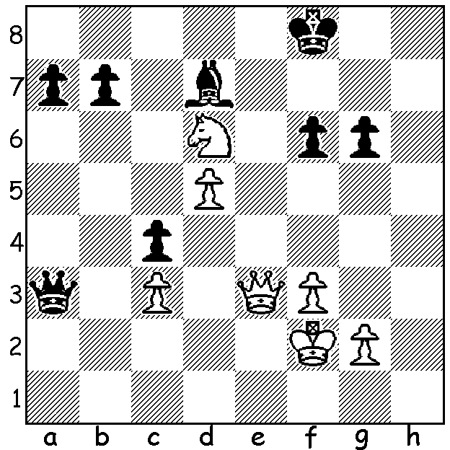
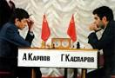
Garry Kasparov vs Stefano Tatai 1986: Karpov vs Kasparov 1984-85 Match
White to play and win:

WORLD CHAMPIONSHIP MARATHON
Continuing our study of Garry Kasparov, we come to his first world championship match against holder Anatoly Karpov. Played in Moscow with the winner needing to win six games, Karpov built up a 4-0 lead after only nine games. After a further 17 draws Karpov won again to be within a point of victory with 27 games played. However he failed to win another game as Kasparov fought back with victories in Games 32, 47 and 48. At this point FIDE President Florencio Camponanes called the match off. Most commentators believe this decision saved Karpov who was clearly under great strain, having lost 10kg during the five month long match, September 1984 to February 1985, and that the cessation was at the behest of the Karpov camp. The length of the match easily eclipsed the previous record of 34 games in the Capablanca vs Alekhine match. A new match was scheduled to take place later in the year over 24 games.

WA ALLEGRO CHAMPIONSHIP
The WA Allegro Championship (9 rds) will be held on Sunday 17 March at the Maccabi Junior Club, Woodrow Ave., in Yokine with time limit of 15min + 2sec. Please check cawa.org.au for details and enrolment (at site entries close at 10am).

SOLUTION: 1.Qh6+ Ke7 (1...Kg8 2.Qxg6+ Kf8 3.Qf7# or 2...Kh8 3.Nf7#) 2.Qg7+! Kd8 (2...Kxd6 3.Qf8+ / 4.Qxa3 ) 3.Qf8+ Kc7 4.Nb5+ Bxb5 5.Qxa3 (Skewer & Discovered Attack both featured in winning the Black Queen).

