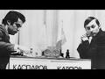
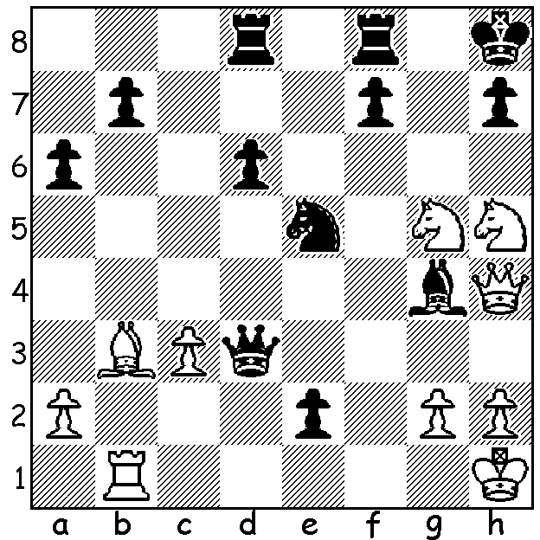

Kasparov vs Elmar Magerramov 1982: Kasparov vs Karpov 1985
White to play and win:

KASPAROV'S REIGN AS WORLD CHAMPION.
The aborted 1985-6 48 game match between Garry Kasparov and Anatoly Karpov was the first five titanic struggles between these two colossi of the chess board for the title of world champion. In Moscow in 1985 with a score of 13-11 Kasparov became, at 22, the youngest ever world champion. He retained the title with a 12.5-11.5 win in 1986, played in London and Leningrad. Then in Seville in 1987 he won the final game to secure a drawn match 12-12. Their final world championship match was played in 1990 in New York and Lyons with Kasparov winning 12.5-11.5. Of their 144 games for the title Kasparov won 21 and Karpov 19 with the remaining 104 drawn. Then in 1993 in London he won 12.7-7.7 against Nigel Short (UK), who had defeated Karpov to earn a tilt at the title. The two participants were expelled from FIDE with the match officially annulled on the grounds the match had not been authorised to be played in London. Kasparov then created the Professional Chess Association and from then until 2007 there were always two claimants to the world title. Kasparov faced future champion Viswanathan Anand (India) in 1995, winning 10.5-7.5. He was due to face Alexei Shirov (Spain) but the attempt to secure sufficient sponsorship failed, as it did for another match against Anand, and so a match was arranged against Vladimir Kramnik (Russia), whom Shirov had earlier defeated. The match in Moscow in 2000 saw Kasparov surprisingly fail to win a game, losing the match 6.5-8.5, thus ending the reign of perhaps the greatest player of all time.

WA ALLEGRO CHAMPIONSHIP
The WA Allegro Championship (9 rds) will be held tomorrow at the Maccabi Junior Club, Woodrow Ave., Yokine, with time limit of 15min + 2sec. Please check cawa.org.au for details and enrolment (at site entries close at 10am).

SOLUTION: 1.Nxf7+! (clearance sacrifice) 1...Nxf7 (1...Rxf7 - this rook is overworked - 2.Qxd8+) 2.Qf6+ Kg8 3.Qg7#.

