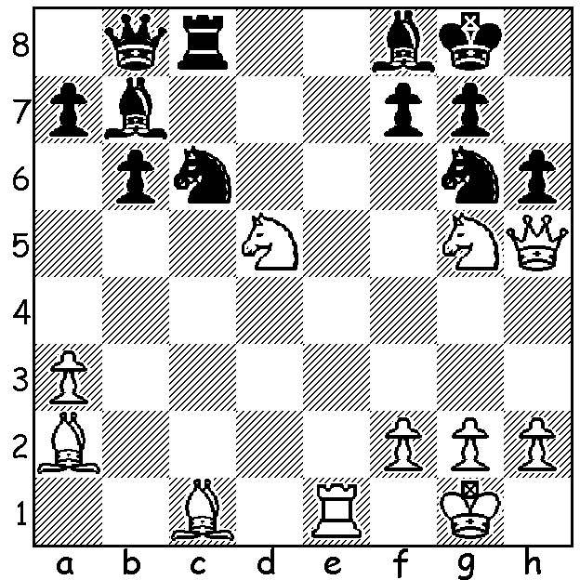

We are postponing the next article
on the life of Garry Kasparov but
here's one of his great finishes,
Garry Kasparov vs Bent Larsen 1987:
White to play and mate in 3:

WORLD TEAM CHAMPIONSHIP
Although not having the prestige of the Chess Olympiads, the World Team Championship, played this year in Kazakhstan, brings together ten of the strongest nations of the world from various geographical zones. Russia were victors with a round to spare, winning seven matches and drawing two. The battle for second place was very close with England with 5 wins, 3 draws (to Russia, India & USA) & 1 loss (to China) coming ahead of China (+4 =2 -2) with India & USA close behind. Other countries represented were, in order of finishing, Iran, Azerbaijan, Kazakhstan, Sweden (who took the place of France) and Egypt. England's success was its best achievement since winning three second places in the 1980s Olympiads and coming first in the 1997 European Team Championship. Representing England were 1.Michael Adams, 2. Luke McShane (individual gold medal), 3. David Howell (individual bronze), 4. Gawain Jones (individual silver).
The Women's championship waswon by China with Russia second.
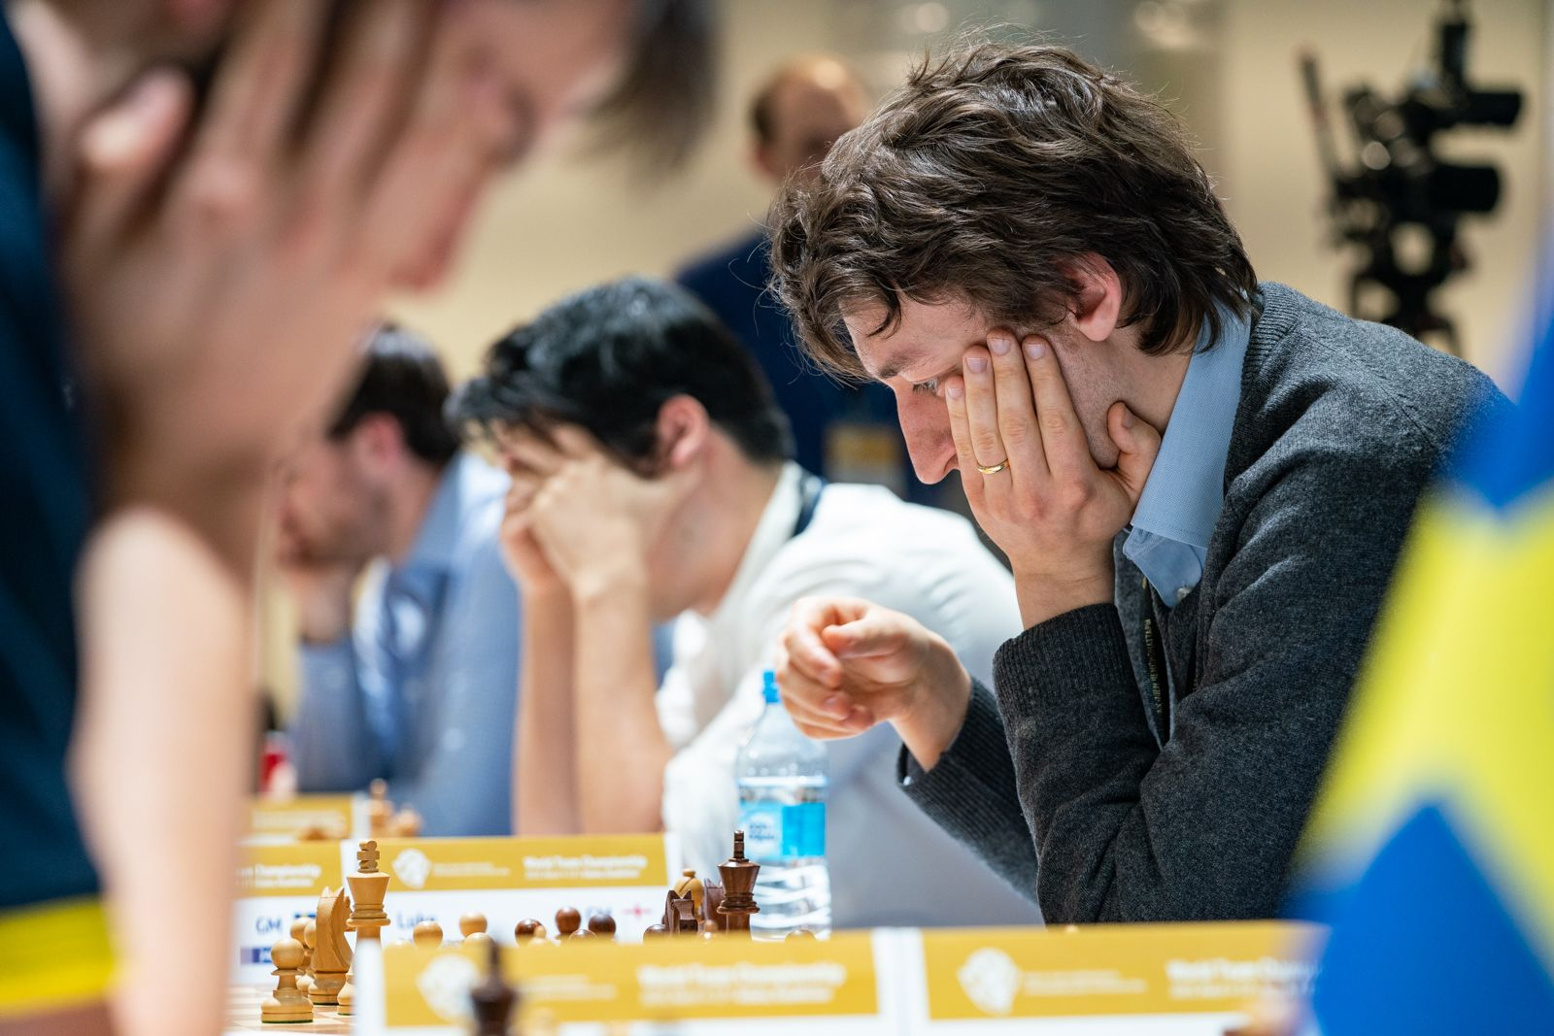
England individual medal winners, McShane, Howell, Jones (R - L)

MARCH BLITZ
For those of you who like their chess to be fast and frantic, head off tomorrow to the Cracovia Club near Whiteman Park and play in the March Blitz (3 mins + 2 sec per move). This event is open to non-CAWA members and starts at 1pm. Please check cawa.org.au for details and enrolment.

SOLUTION: 1.Qxg6!! (deflection sacrifice) 1...fxg6 (1...hxg5 2.Nf6+ Kh8 3.Qh7#) 2.Nf6+ Kh8 3.Nf7#.

