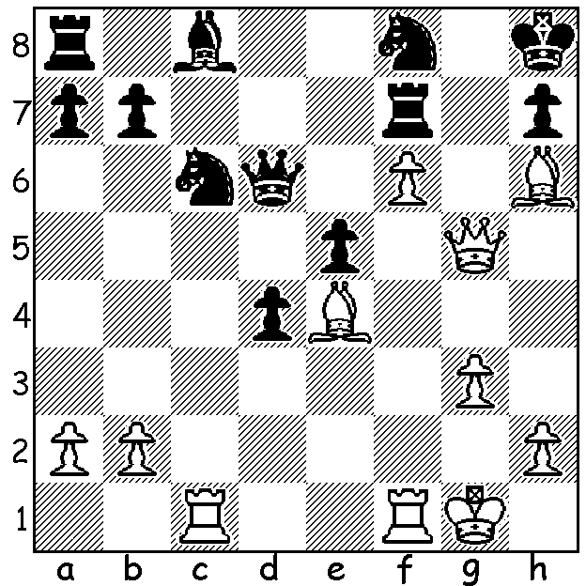
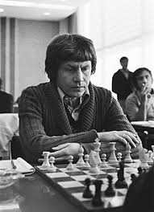
Runner-up to Anatoly Karpov in the World
Junior Championship, Andras Adorjan (Hungary)
suffered a heart attack while playing but survived.
White against Krunoslav Hulak he mates in 4:

HEART ATTACKS AT THE CHESS BOARD
I have been researching players who have died at the board or very soon after a game. The most recent tournament to experience heart attack deaths was the 2014 Olympiad in Tromsi, Norway, where two players died within hours of each other, a Seychelles player collapsing in a middlegame and an Uzbek player found dead in his hotel room. The most dramatic death was in 1931 when Andras Wachs (Hungary) checkmated an opponent whose head dropped on the table or board and he was pronounced dead. In similar vein in 1944 in Kansas City Al Harowitz's opponent died of a heart attack after Harowitz had made a spectacular move. Efim Bogolubov, who twice challenged Alexander Alekhine for the world title, succumbed to a heart attack after completing a simultaneous display in 1952. Two Australian players to fall victim were Cecil Purdy, Australian champion on a number of occasions and a World Correspondence champion, during a Sydney Championship game, and a WA champion Jim Raudzins who died while playing at the Metro club Christmas wind-up doubles (I believe his partner had just made a losing move). It seems the surge in adrenaline often coupled with time troubles can significantly contribute to the possibility of an attack .What directed me to such morbid thoughts was the fact that I suffered a heart attack myself towards the end of my final round game in the Southern Suburbs Open on the 19th of this month. Fortunately it didn't stop my winning a B + 3p v N + 2p ending and also an ambulance was able to get me to hospital in time to have a succesful operation to unblock a heart artery and insert a stent.

SOLUTION: 1.Qg7+! Rxg7 2.fxg7+ Kg8 3.gxf8=Q+ (or 3.Rxf8+) 3...Qxf8 4.Rxf8#.

