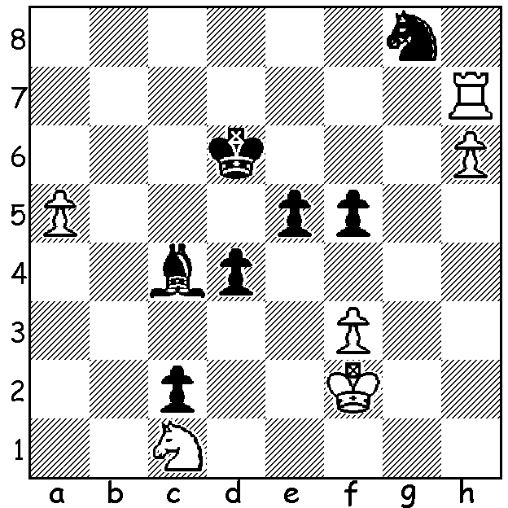

The 2019 US Championships are under way.
Here is a position from the event, Awonder
Liang vs Varuzhan Akobian. Black now
plays 1...e4 but is surprised by White's next.
Can you see how White wins and what should
Black have played?

CONGRATULATIONS TEMUR KUYBOKAROV
Nineteen year old Temur Kuybokarov, who
earlier this year was highlighted in the West
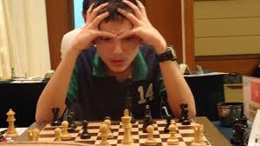
as one of WA's outstanding young achievers,
has now received official notification that he
has been awarded the title of Grandmaster.
Temur has been residing in WA for the past
two years and in that time has won the 2018
WA Lightning (Blitz) Championshipand the
2018 & 2019 WA Allegro (Rapidplay)
Championships besides giving two
Simultaneous Displays (unbeaten ). In January
he won the Australian Open in Melbourne and
has recently been playing in the Sharjah Masters
(4/6 score my latest information) before moving
on to compete in the Dubai Open.

WA JUNIOR CHAMPIONSHIPS
The WA Junior Championships will be played at Corpus Christi College, Bateman, Monday 15 to Thursday 18 April. Details and entry on cawa.org.au

GUFELD CUP
The Gufeld Cup (Easter Open) will be played on Sunday 21 & Monday 22 April at Leeming Primary. Details & entry on cawa.org.au

SOLUTION: 2.Rd7+! and queens the h pawn. 1...Nf6 would have left Black with reasonable chances of saving the game.

