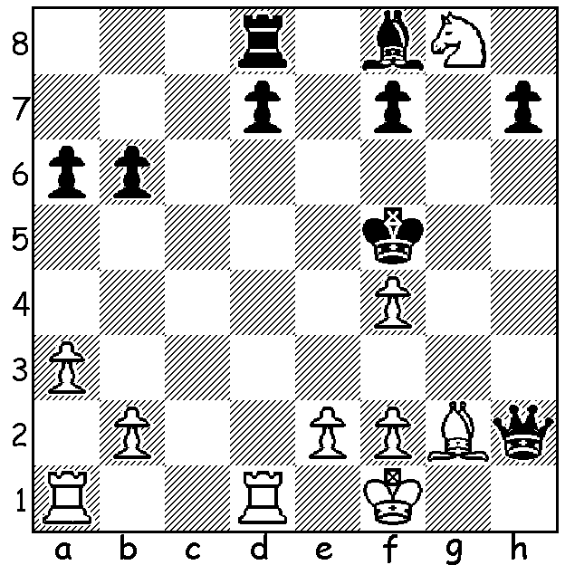
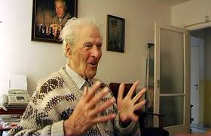
A prominent Russian GM, Andor Lilienthal died three days after his 99th birthday.
Lilienthal vs Mier Romm 1930, mates in 4:

CHESS AND LONGEVITY
After a recent article on chess players dying of heart attacks readers may have come to the conclusion that the stress of playing serious chess is likely to be harmful or even fatal. Australian David Smerdon, an academic and GM, has contributed to a study comparing the the life expectancy of GMs with Olympic medalists and the general population. Results show GMs lived up to 14 years longer than the general population and that top chess players appear to have similar patterns of longevity as Olympians. One might find such results surprising as chess players spend a considerable time sitting, both playing and studying, but an earlier Polish study showed chess players exhibited a higher level of physical fitness than the general population. However attaining the exalted GM title may increase life expectancy through psychological, social and economic boosts.

WA JUNIOR CHAMPIONSHIPS
The Wa Junior Championships will be played at Corpus Christi College, Bateman, Monday 15 to Thursday 18 April. Details and entry on cawa.org.au

GUFELD CUP
The Gufeld Cup (Easter Open) will be played on Sunday 21 & Monday 22 April at Leeming Primary. Details & entry on cawa.org.au

SOLUTION: 1.Rd5+ Kxf4 (1...Kg6 2.Rg5#) 2.e3+ Kg4 3.Nf6+ Kh4 4.Rh5#.

