Viswanathan Anand vs Vassily Ivanchuk
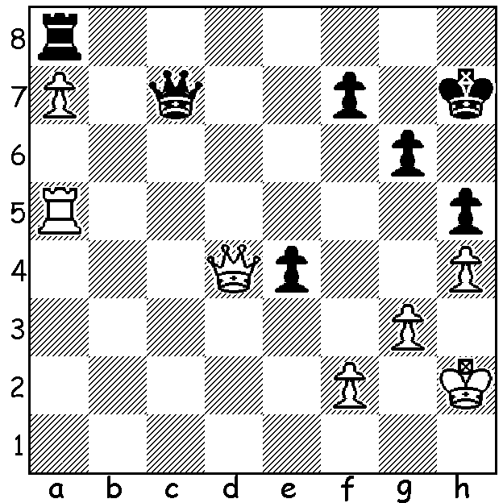
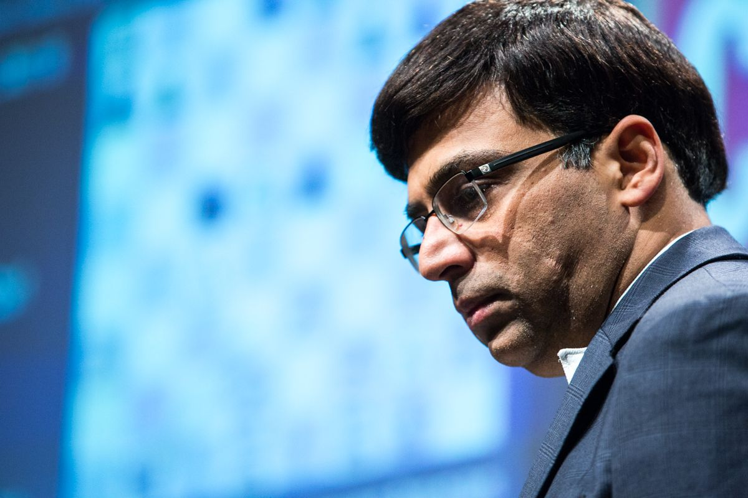
2004: White to play and win (3 moves):

Viswanathan Anand

CHESS PLAYERS AND FITNESS

The unforgiving nature of the game of chess means that hours of effort to build up a good or winning position can be ruined by one error. How important it is then for players to sustain their levels of concentration throughout a game and also a tournament that might last for weeks. Among players there is a growing understanding that physical fitness can improve mental fitness, cognition and stamina. Almost all the leading professionals lay emphasis on their physical fitness in preparation for tournaments with world champion Magnus Carlsen working out daily on the treadmill as well as playing soccer, beach volleyball and tennis and being one of a number of players who employ a fitness coach. His predecessor Vishy Anand, the only player over 40 in the world top ten, goes for two hours to the gym regularly, cycles, swims and goes on long walks while Wesley So jogs an hour each day. Before his successful challenge to Jose Capablanca in 1927 Alexander Alekhine gave up smoking and drinking and underwent a program of physical training which helped him come out on top in a gruelling match lasting 34 game. However it is believed his resumed drinking habits contributed to his surprise loss to Max Euwe in 1937 by 14.5-15.5 before he again gave up drinking to comfortably defeat Euwe in 1937 by 15.5-9.5.

GUFELD CUP
The Gufeld Cup (Easter Open) will be played tomorrow, Sunday 21, & Monday 22 April at Leeming Primary. Details & entry on cawa.org.au

SOLUTION: 1.Rxh5+! gxh5 2.Qxe4+ Kg7 3.Qxa8.

