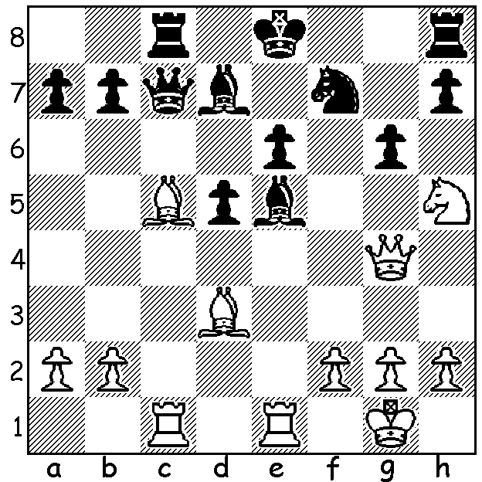
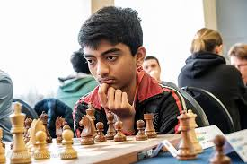

Gukesh Dommaraju vs Dinesh Sharma 2019:
sacrifices lead to an overwhelming material gain
for White (5 moves):

SECOND YOUNGEST GRANDMASTER EVER
Gukesh Dommaraju became the second youngest player to gain the GM title earlier this year at the Delhi International GM Open. He was unbeaten in scoring 7/9 to gain his third qualifying norm, finishing the tournament with the brilliant sacrificial win shown here. The youngest ever GM was Sergey Karjakin (formerly Ukraine, now Russia) who narrowly lost his World Championship match against Magnus Carlsen (GM at 13y, 4m, 27d) 1-3 in the tie break after the match had been drawn 6-6 (one win each). Karjakin was 12 years, 7 months and 0 days old when he became a GM while Gukesh was 17 days older. Gukesh comes from Chennai, the same city as Vishy Anand, and attended Anand's chess school, as did Praggnanandhaa Rameshbabu, a GM at 13 and a year older than Gukesh. Gukesh became hooked on the game when the Anand vs Carlsen World Championship was held in Chennai in 2013.

SOLUTION: 1.Ng7+!! (deflection) 1...Bxg7 2.Rxe6+! Kd8 (2...Bxe6 3.Qxe6 Kd8 4.Be7+!
Qxe7 5.Q/Rxc8# or 4...Ke8 5.Bd6+) 3.Be7+! Ke8 4.Bd6+ Kd8 5.Bxc7+ Rxc7 6.Rxc7 Kxc7
7.Qf4+ resigns.1.Qxg6!! (deflection sacrifice) 1...fxg6 (1...hxg5 2.Nf6+ Kh8 3.Qh7#) 2.Nf6+
Kh8 3.Nf7#.

