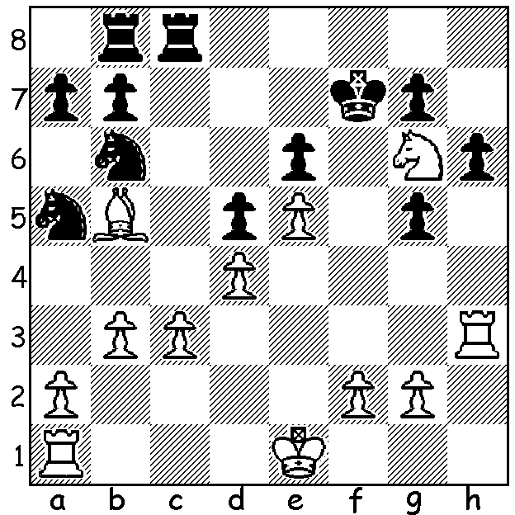
Garry Kasparov vs Viktor Korchnoi, 2001:
Can you work out a successful king hunt for
White (7 moves)?

KASPAROV IN RETIREMENT
Getting back to our series on world champions we conclude a four part look at the life of Garry Kasparov. Although he had lost the title in 2000 he remained world number 1 rated player and the most successful tournament player until his retirement in 2005. Naturally such a charasmatic and energetic person would not fade into oblivion, instead devoting his time to writing, coaching and politics. He wrote a five volume book series 'My Great Predecessors' with stories of the top players from Steinitz to Karpov with an extensive collection of games with detailed analysis. He was also in
demand as a coach with Vishy Anand, Haikaru Hakamura and a youthful Magnus Carlson among those benefitting from his skill. In 2014 he challenged incumbent Kirsan Ilyumzhinov for the presidency of FIDE but lost 61-110. In politics he took a leading role in opposition to Putin both in organisation and protests and planned, as the nominee of the Other Russia party, to oppose Putin in the presidential election before government obstacles prevented his standing. He was arrested and attacked at demonstrations on more than one occasion, including one in support of the imprisoned punk band Pussy Riot. Rumours abounded that he was on a secret police hit list and he left Russia for good in 2013 to become a citzen of Croatia but he continued to criticise Russia for its lack of democracy and its foreign policy including its involvement in Syria and its annexation of Crimea.

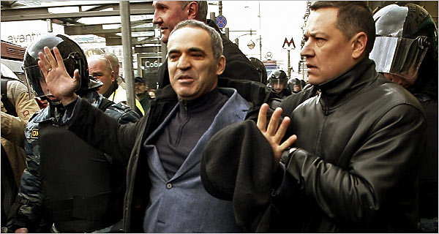
Kasparov arrested in Moscow 2007

SOLUTION: 1.Rf3+! Kxg6 (1...Kg8 2.Ne7+) 2.Bd3+ Kh5 3.Rh3+ Kg4 4.f3! Kf4 5.Kf2 g4 6.g3+ Kg5 7.f4#.

