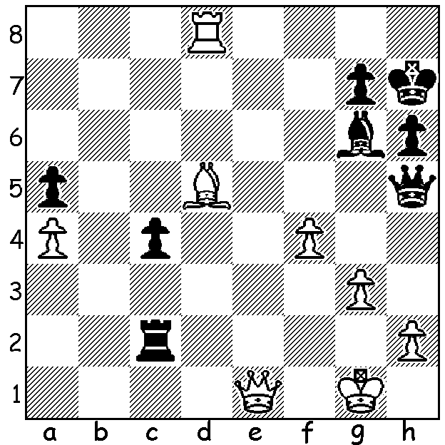

Anatoly Karpov vs Miguel Najdorf 1982:
White to play and mate in 5:

ANATOLY KARPOV'S ROAD TO WORLD CHAMPION
Anatoly Karpov, born in 1951 in the Urals in Western Russia, learnt chess at the age of four and aged twelve entered the prestigious Botvinnik chess school in Moscow where Botvinnik was doubtful at first of his potential. However he was an excellent and ambitious student and went on to win the World Junior Championship in 1969 (+9 =2). He qualified for the 1974 Candidate matches and defeated Lev Polugaevsky +3 =5 leading to a semi-final against former champion Boris Spassky. He was somewhat pessimistic about his chances but, despite losing the first game got through by +4 -1 =6. He then won the final against Viktor Korchnoi, which was to be the start of a extended and tense rivalry, in a long match by +3 =9 -1. Opinion was divided on his chances against world champion Bobby Fischer but negotiations for the match broke down after FIDE refused to agree to all of Fischer's many demands for the match. Fischer then announced he would not defend his title and Karpov was declared world champion.

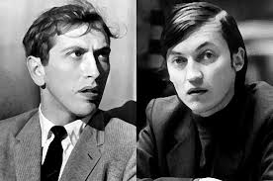
The match that wasn't played, Fischer vs Karpov

WA CHAMPIONSHIP
The WA Championship will be played on Sundays from May 19 to June 30 at Leeming Primary. Players of all standards invited as there will be a number of rating prizes. Info and entry - cawa.org.au

SOLUTION: 1.Bg8+ Kh8 2.Bf7+! Kh7 3.Rh8+! Kxh8 4.Qe8+ Kh7 5.Qg8#.

