Anatoly Karpov vs Viktor Korchnoi
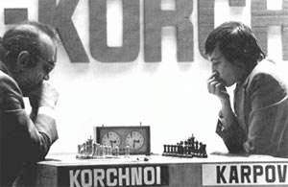
(World Ch 1978): White brings off a
spectacular win (3 moves):
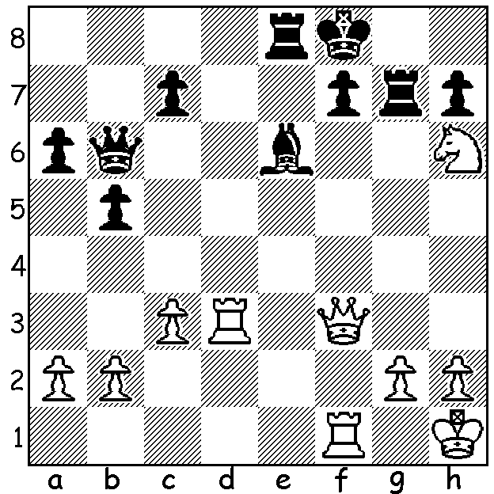

ANATOLY KARPOV AS WORLD CHAMPION

Having won the the world championship by default from Bobby Fischer, the 24 year old Anatoly Karpov was determined to prove himself a worthy champion, participating in nearly every major event for the next ten years, creating a a phenomenal streak of tournament wins and leaving no one doubting that he was the strongest player in the world. His first title defence was against Russian defector Viktor Korchnoi whom Karpov had defeated +3 -2 =9 in the 1974 Candidates Final. The match for the world championship was to be just as closely fought and was noted for the extreme animosity between the Russian team and the Western group of Korchnoi supporters with accusations, claims and counter claims keeping the refereeing team busy throughout the match. The Korchnoi team even accused the Russians of employing a para-psychologist seated at the front of trying to hypnotise their player. While Korchnoi was the more dynamic player, errors, some in time trouble, led to Karpov gaining a three point advantage (+5 =20 -2). Korchnoi rallied to win three of the next four games to equal the score before Karpov won game game 32 to hold on to the title. Korchnoi was again challenger three years later but the older man was now past his best, losing +2 =10 -6. Karpov's next opponent was Garry Kasparov and their series of matches for the title from 1984 to 1990, in which the total scores were Karpov 19 wins, Kasparov 21 wins with 104 draws, were related in March 16 & 23 columns

SOLUTION: 1.Rd7!! (brilliant, attacking f7 a 4th time): if 1.Bxd7 2.Qxf7+! Rxf7 3.Rxf7#. Black played 1...Rb8 but after 2.Nxf7! Bxd7 3.Nd8+ resigned (3...Kg8/Ke7/Ke8 4.Qf8#).

