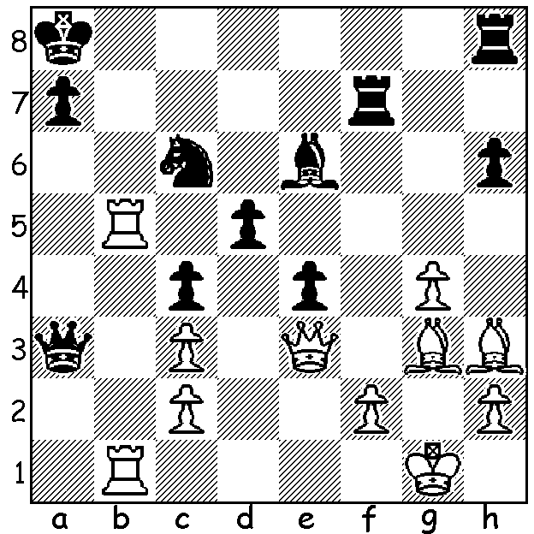
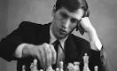
Bobby Fischer vs Raymond Weinstein 1960:
White to play and win (3 moves):

A FLAWED GENIUS

Anatoly Karpov's immediate predecessor as world champion was the flawed American genius Bobby Fischer. Born in Chicago in 1943 he was brought up by his mother who gave him and his elder sister a chess set when he was six. He won the US Junior Championbship when 13 and the US Championship for the first time a year later. The Grandmaster title soon followed and he he went on to single-handedly take on the Soviet chess organistaion in pursuit of the world title. In the 1971 Candidates matches he swept his opposition aside, former Soviet champion Mark Taimanov 6-0, Bent Larsen, who played above Fischer in the USSR v Rest of World match, again 6-0 and then former world champion Tigran Petrosian 6.5-2.5. He then went on to defeat world champion Boris Spassky 12.5-8.5 in a match with as much drama off the board as on. His obstinancy in negotiations for a match against Anatoly Karpov led to FIDE depriving him of the title and Fischer retiring. After being enticed to play another match against Spassky which broke US embargoes on trade with Serbia he became a pariah, on the run from US authorities. He was arrested in Japan but released and was granted citizenship in Iceland. He died in January 2008 and was buried near Reykjavik, the city where he had won the world title.

SOLUTION: 1.Qxh6!! Rxh6 2.Rb8+ Nxb8 3.Rxb8# (if 1...Re8 2.Qxe6!).

