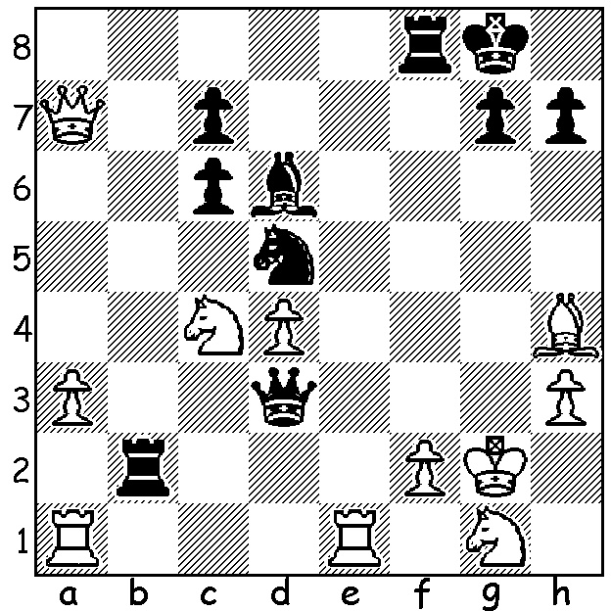

Ray Robson vs Samuel Sevian
(US Championship 2019)
Black has sacrificed a piece for an attack:
Now he wins quickly (3 moves)

US CHAMPIONSHIP

It's now two months since the conclusion of the US Championship concluded. Three players, Fabiano Caruana, Liener Dominguez and Hikaru Nakamura, were tied on 7/10 going into the final round. In his final game Caruana drew with 2018 champion Sam Shankland and Dominquez failed to win a difficult queen ending with knight against passed pawn on the 7th against bottom placed Timur Gareyev, while Nakamura defeated early leader Jeffrey Xiong to finish on 8/11 (+5 =6) to secure his fifth championship.
In the Womens Championship winner was 17 year old Jennifer Yu who scored a fantastic 10/11, conceding only two draws and winning by two and a half points.

WA CHAMPIONSHIP

The state championship kicked off last Sunday at Leeming with two of the favourites suffering surprise defeats with FM Patrick Gong losing to WFM Kathryn Hardegen and former champion FM Stephanus Kurniawan losing to Derek Elkington. With one game postponed the only other result was the draw between two other former champions FM Tristan Boyd and Tim Hare. If you haven't played through Derek's win, please do so - very impressive play reminding me of Gary Kasparov's wins with the Kings Indian.

SOLUTION: 1...Rxf2+ 2.Bxf2 Qg3+ resigns (mate next move on h2 or f2).

