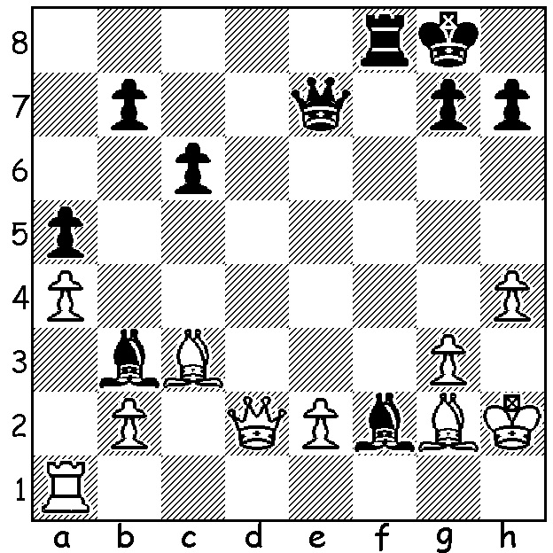

Anna Zatonskih vs Jennifer Yu
(US Womens Championship 2019)
Black wins quickly.

JENNIFER YU

Correction: winner of 2019 US Womens Championship was Jennifer Yu not Carissa Yu. Having cleared that up I thought I'd write about Jennifer this week. Now 17, she was born in New York February 1, 2002 and started to play in Grade 1, attending an after-school chess activity group. She was hooked on the game and persauded her parents to hire a chess coach for her. She was winner of the Girls Under 12 Youth Championships in South Africa in 2014 and a year later became the youngest and first female champion of Virginia. She was US Girls champion 2014-16 and was a member of the 2018 US Women's Olympiad team, winning bronze medal for Bd 5. And then this year came her victory in the US Womens Championship scoring 10/11, conceding only two draws and winning by two and a half points.

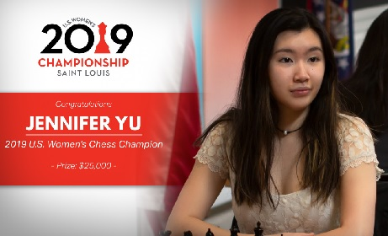

WA CHAMPIONSHIP

Only two games were played last Sunday in Round 2 with Ihsan Ferozkohi (now leading with 1.5/2) drawing with past champion Stephanus Kurniawan and Patrick Gong defeating Derek Elkington.
In the Reserves Ian McAteer and CAWA President Alan Wolstencroft are the only players to win their first two games.

SOLUTION: 1...Bxg3+! 2.Kxg3 Qc7+ 3.Kg4 Be6+ & White resigns (mate follows).

