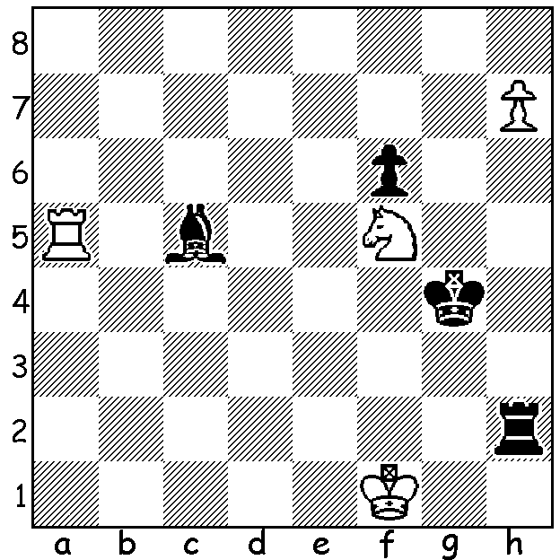
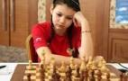
Aleksandra Goryachkina vs Valentina Gunina
(Womens Candidates 2019): How can White win?

WOMENS CANDIDATES TOURNAMENT

The Womens Candidates Tournament being played in Kazan, Russia, has eight of the top women competing in a 14 round competition to find a challenger to Womens World Champion Ju Wenjun. Only missing is women's top rated player Hou Yifan who would have liked to have played but gave precedence to her studies at Oxford University. After nine rounds Aleksandra Goryachkina is a
runaway leader with 7.5/9, 2.5 pts ahead of her nearest rival Kateryna Lagno (5). Alexsandra, aged 20, is the youngest competitor but has already been Russian Womens Champion twice as well twice being World Girls Under 20 Champion. Of note was her 2nd in the 2013 Russian Under 19 Championship when she competed against Russia's top boys.

WA CHAMPIONSHIP

After 3 rounds two former champions, Tristan Boyd and Tim Hare lead with 2.5/3 after Tristan defeated Derek Elkington and Tim beat Kathryn Hardegen. Talevera Juan Rodriguez defeated Stephanus Kurniawan while Partick Gong drew with Ihsan Ferzkohi.
In the Reserves Ian McAteer maintained his perfect score defeating CAWA President Alan Wolstencroft. Close behind are Dominador Andador and junior Rebo Fu Ye on 2.5.

SOLUTION: 1.Nh4!! (a brilliant deflection sacrifice): if 1...Kxh4 2.h8=Q or 1...Rxh4 2.Ra4+ Kg3/5 3.Rxh4 Kxh4 4.h8=Q. Black played 1.Kg3! and the game continued 2.h8=Q Rf2+ 3.Ke1 Bb4+ 4.Kd1 Bxa5 with White winning 17 moves later.

