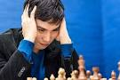
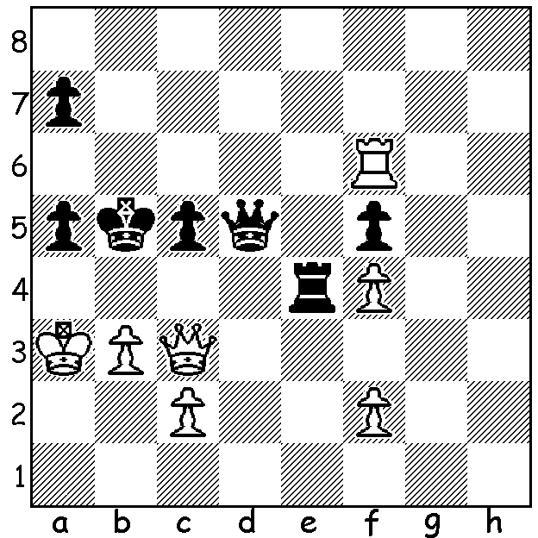
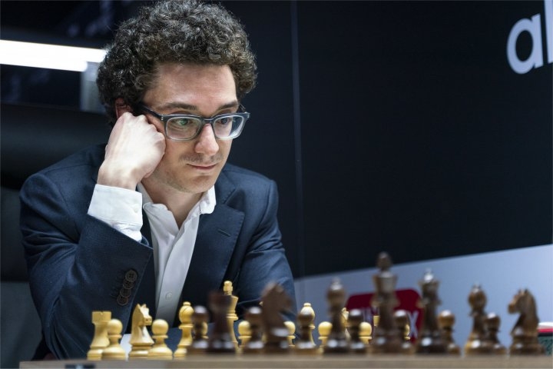
Fabiano Caruana vs Wesley So (Norway 2019, Armegeddon game):
White missed a sensational move which would have won in 4 moves.
Can you find it?

ARMEGEDDON IN NORWAY

Digital chess clocks have been a boon to the game, especially with the employment of Fischer time controls which can add between 3 and 30 seconds to a player's time after each move. In the recent Armegeddon tournament in Stravanger, Norway, ten of the world's top players competed in an event in which replays took place after initial draws. In each main game after two hours players were given 10 seconds a move extra while after draws Armegeddon replays were played with the same colour with White given 10 minutes and Black 7, with 10 second increments for players only after 60 moves. A win in the main game gained two points while a draw scored a half point. If an Armegeddon game was required White would gain a point for a win while Black would get the point with a win or draw. The event was won by a large margin by world champion Magnus Carlsen despite suffering his only defeat in his final game, an Armegeddon against Fabiano Caruano. Top scores: Carlsen 13.5/18, Levon Aronian and Yu Yangi (the only player rated below 2750) 10.5, Caruana and Wesley So 10.

WA CHAMPIONSHIP

A full round was played last Sunday with former champions Tristan Boyd (win v Derek Elkington) and Tim Hare (win v Ihsan Ferozkohi) both advancing to 3.5/4. Patrick Gong suffered his second defeat, this time to another former champion Stephanus Kurniawan while WA Women's champion Kathryn Hardegen scored her second win (v Juan Rodriguez Talavera).
In the Reserves Ian McAteer dropped to equal second with a loss to Dominador Andador who takes over the lead with 3.5/4.

SOLUTION: 1.Qe5!! (a brilliant clearance sacrifice freeing the c pawn, main threat 2.Qb8+): if 1...Rxe5 2.c4+ Qxc4 3.bxc4+ Kxc4 4.fxe5. If 1...Qxe5 the same sequence wins. Instead Caruana played 1.Qh3 with So drawing with 1...Qd1!! allowing 2.c4 Rxc4 3.bxc4+ Kxc4 as White would not be able to avoid a perpetual check.

