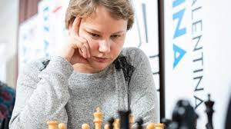
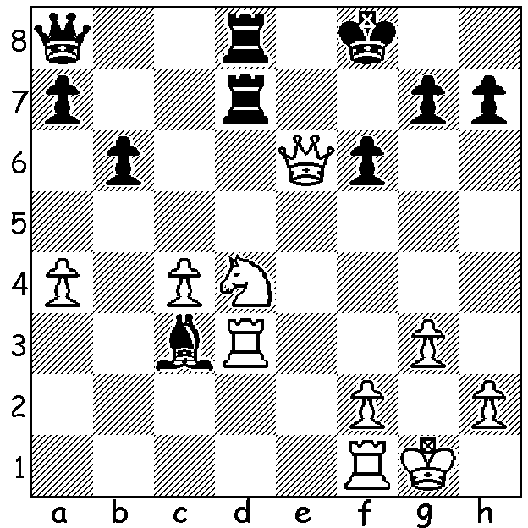
Valentina Gunina vs Mariya Muzychuk Valentina Gunina
(Womens Candidates 2019):
White to play and win

WOMENS CANDIDATES TOURNAMENT
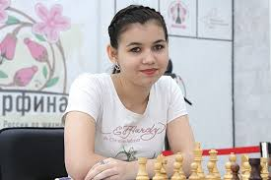
As reported two weeks ago the Womens
Candidates Tournament played in Kazan,
Russia, had eight of the top women
competing in a 14 round competition to
find a challenger to Womens World
Champion Ju Wenjun. Russian Aleksandra
Goryachkina, the youngest competitor at
twenty, was runaway winner, securing top
place after 12 rounds before finishing with
9.5/14 and, like Magnus Carlsen in Norway
recently, only losing her final game. The
match between Alexsandra and Ju Wenjun Aleksandra Goryachkina
will take place later this year (details still to
be finalised).

WA CHAMPIONSHIP
After 5 rounds, with Tim Hare losing to Ihsan Ferozkohi, Tristan Boyd took overall lead after drawing with Stephanus Kurniawan while Kathryn Hardeggen defeated Derek Elkington. Leading scores: Boyd 4/5, Hare 3.5, Ferozkohi & Hardegen 3/5.
In the Reserves Dominador Andador maintained his lead with victory over CAWA President Alan Wolstencroft and leads Alex Janeski by a half point.

WA BLITZ CAHAMPIONSHIP
The WA Blitz Championship will be played Sunday 14 July at Leeming Primary, 1pm - 4pm. Details cawa.org.au and entries to Andrew Hardegen (andrewhardegen@iinet.net.au or 0407421084).

SOUTH OF RIVER CHESS OPEN
The Southern Suburbs Chess Club supported by the City of Melville invites entries to the inaugural South of River Open to be held on five successive Wednesdays at the Bullcreek Community Centre starting July 10 at 7pm. Players of any experience or ability are welcome. Entries ianmcateer@live.com and further details cawa.org.au

SOLUTION: 1.Nf5! (1...Rxd3 2.Qe7+ Kg8 3.Qxg7#). Now after 1...Qb7, rather than 2.Rxc3 White played 2.Nh6? and after 2...gxh6 only drew. Short of time White not surprisingly missed 2.Qe7+!! (2...Rxe7 3.Rxd8+ Kf7 4.Nd6+ / 5.Nxb7 or 2...Kg8 3.Qxd8+ Rxd8 4.Rxd8+ Kf7 5.Nd6+ / 6.Nxb7).

