GRAND CHESS TOUR, CROATIA
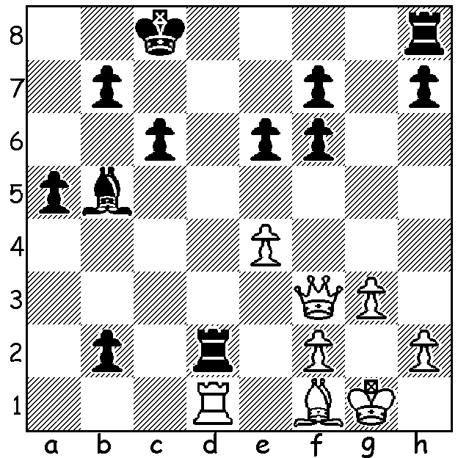
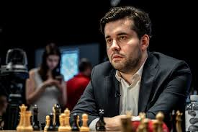

Shakhriyar Mamedyarov vs Levon Aronian Ian Nepomniachtchi

(Grand Chess Tour, Croatia, 2019):
The always imaginative Aronian (Black) sacrificed a piece and then his queen to reach this position. He now played 1...Rhd8 which should win (but only drew). Can you find the alternative move which leads to an easy win?

The current Grand Chess Tour event being played in Zagreb, Croatia, with twelve of the best players in the world competing has a surprise leader in Russian Ian Nepomniachtchi with 4/5, a point ahead of world champion Magnus Carlsen and Wesley So. However Nepomniachtchi still has to play Carlsen. A former unsuccessful challenger to Carlsen, Sergey Karjakin, claimed Carlsen doesn't know openings and gets into bad positions. Here's their opening moves in their Rd 5 draw (Carlsen Black): 1.d4 d5 2.c4 e6 3.Nf3 a6 (Janowskis Defence) 4.cxd exd 5.Nc3 h6.

WA CHAMPIONSHIP
The WA Championship was thrown open with leader Tristan Boyd losing to Patrick Gong allowing Ihsan Ferozkohi to catch up after defeating Kathryn Hardegen. With both players on 4/6 there is a strong likelihood of a tie and play-off for the title.
In the Reserves Andador Dominador (5.5/6) has claimed the title with a round to go after defeating Alex Janceski. Running second are Rebo Fu, Ben Dagza and Alan Wolstencroft on 4/6.

WA BLITZ CHAMPIONSHIP
The WA Blitz Championship will be played Sunday 14 July at Leeming Primary, 1pm - 4pm. Details cawa.org.au and entries to Andrew Hardegen (andrewhardegen@iinet.net.au or 0407421084).

SOUTH OF RIVER CHESS OPEN
The Southern Suburbs Chess Club supported by the City of Melville invites entries to the inaugural South of River Open to be held on five successive Wednesdays at the Bullcreek Community Centre starting July 10 at 7pm. Players of any experience or ability are welcome. Entries ianmcateer@live.com and further details cawa.org.au

SOLUTION: 1...Be2!! (interruption sacrifice disrupting the queen's defence of d1): if 2.Bxe2 Rxd1+ 3.Bxd1 b1=Q or 2.Qxe2 Rxe2 3.Bxe2 a4 and the passed pawns are unstoppable.

