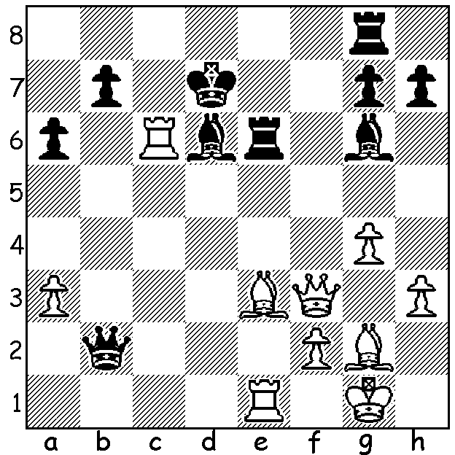

Anish Giri vs Shakhtiyar Mamedyarov
(Grand Chess Tour, Croatia, 2019):
White's previous move (rxpc6+) offered
a rook which could not be captured:
how does he continue the fireworks?

GRAND CHESS TOUR, CROATIA
The recently completed Grand Chess Tour event played in Zagreb, Croatia, with twelve of the best players in the world competing, was won by world champion Magnus Carlsen with a score of 8/11, a point ahead of Wesley So. Other scores: Levon Aronian, Fabiano Caruana 6, Anish Giri, Ian Nepomniachtchi, Ding Liren 5.5, Sergey Karjakin 5, Viswanathan Anand, Shakhriyar Mamedyarov Maxime Vachier-Lagrave 4.5, Hakaru Nakamura 4. This latest tournament success, Carlsen's eighth in a row, extending his unbeaten streak in classical games to 79, brought his rating to 2882, equal to his previous highest.

WA CHAMPIONSHIP
As expected the WA Championship finished in a tie between Tristan Boyd and Ihsan Ferozkohi who won their final games against Juan Rodriguez Talavera and Derek Elkington respectively to finish with 5/7. A two game play-off will decide the title.

WA BLITZ CHAMPIONSHIP
The WA Blitz Championship will be played Sunday 14 July at Leeming Primary, 1pm - 4pm. Details cawa.org.au and entries to Andrew Hardegen (andrewhardegen@iinet.net.au or 0407421084).

SOLUTION: 1.Rxa6! (a deflection and clearance sacrifice). Again the rook cannot be taken - 1...bxa6 2.Qc6+. Black played 1...Rb8 but was totally lost 6 moves later and resigned.

