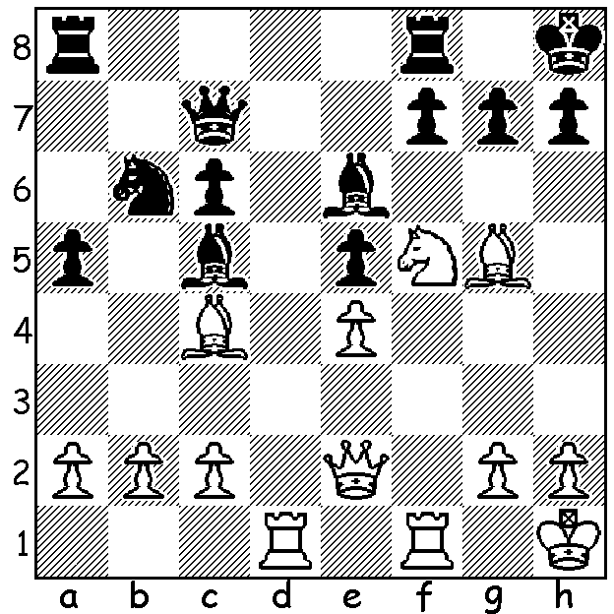
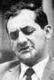
Leonid Stein vs Lajos Portisch
(Interzonal 1962) White to play and win

LEONID STEIN

Perusing a volume of Garry Kasparov's My Great Predecessors for information on Boris Spassky I discovered a chunk of the chapter was devoted to Leonid Stein (born in Ukraine, 1934), certainly a lesser name to non-Russian and non-Ukranian players. This unfamiliarity can be attributed to the number of times Stein was the victim of a FIDE ruling limiting the number of USSR players in the Interzonal and Candidate tournaments, events to find a challenger to the world champion. This ruling sought to minimise the risk of Soviet players sacrificing games to benefit a higher placed compatriot but it must have been galling to Stein to see players qualifying for these events who scored less than he did. At his peak he was one of the world's top ten players and his achievements included winning the USSR championship three times and playing for USSR in Olympiads on a number of occasions, including Bd 1 in Helsinki in 1961 where he scored +8 =3 -1. In 1973 he had qualified for the Petropolis Interzonal and was touted as a possible Candidates winner. However as he was preparing to leave with the Soviet team for the European team championships he suffered a fatal heart attack aged only 38 and at the peak of his career.

SOLUTION: 1.Nxg7! Bxc4 (1...Kxg7 2.Bf6+ Kg8 3.Qh5 Rfd8 4.Qh6 Bf8 5.Qg5+ mates or 2...Kh6 3.Qe1 mates) 2.Bf6!! Be7 (2...Bxe2 3.Nf5+ Kg8 4.Nh6#) 3.Qf3 Nd7 4.Rxd7! Qxd7 5.Nh5+ mates.

