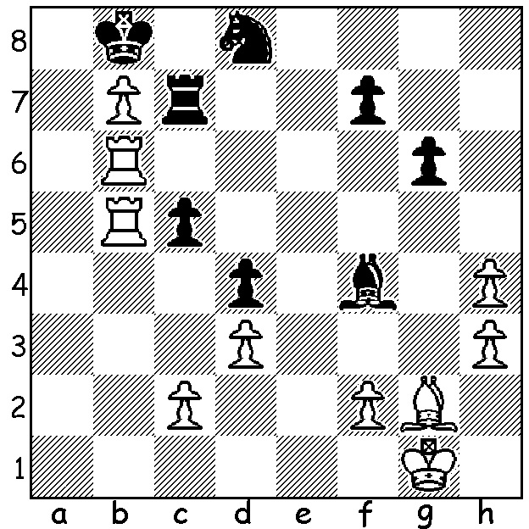

Gordon Thomas Crown vs Alexander Kotov (GB vs USSR, Bd 4, 1947)
After sacrificing a piece for 2 pawns for an attack on Black's king, White now brings
about Black's resignation in 2 moves:

GORDON THOMAS CROWN

After last week's article on Leonid Stein who died at the early age of 38 I am following up with an article on a player who died tragically at the age of 18, Gordon Thomas Crown. Born in Liverpool, England, in 1929, he learnt to play when nine. He was runner-up in the 1946 British Boys Championship, won the 1946-47 Hastings Reserves section and was third in the 1947 British Championship. Chosen to represent Britain, he scored 1.5/2 vs the Netherlands and then in radio matches he won his game vs Australia and won one and lost one game vs Alexander Kotov on Bd 4 vs USSR. Sadly late the same year he suffered peritonitis resulting from a burst appendix and died during an operation. Certainly a personal tragedy as it appears that before his hospitalistion a doctor had failed to diagnose the possibility of appendicitis and also a tragedy for the British chess community in losing someone with the potential to be the country's first Grandmaster. In fact it wasn't until 1976 that Britain gained its first UK born GM, Tony Miles (although the naturalised Jacques Mieses was awarded the title in 1950).

SOLUTION: 1.Ra6! threatening 2.Ra8+ & forcing 1...Nxb7: White now plays the Switchback 2.Rab6 & Black resigns (if 1...Rxb7 2.Bxb7 Nxb7 again 3.Rab6).

