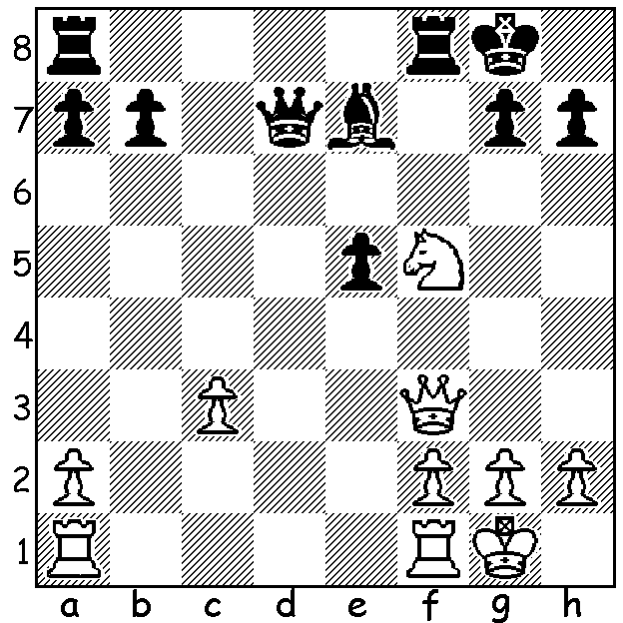
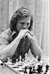
Tony Miles vs Jan Timman 1985
White to play and win (3 moves)

TONY MILES

Last week I mentioned Tony Miles as the first UK born Grandmaster. Born in 1955, he was British Under 21 champion 1968 & 1971 and was runner-up in the World Junior Championship in1973 where he defeated the winner, Alexander Beliavsky. He was awarded the GM title in 1976, won the British Championship in 1982 and was ranked ninth in the world in 1984. He was Bd 1 for England in the 1984 & 1986 Olympiads, helping the team to silver medals in each. His string of victims included three former world champions, Smyslov, Tal & Spassky and he also defeated the then world champion Anatoly Karpov in 1980 using the unorthodox defence 1.e4 a6 (he also defeated Karpov in 1983). He was hospitalised after a mental breakdown in 1987 and later moved to USA & Australia (runner-up in 1991-92 Australian Championship) before returning to England. A diabetic, he died of a heart attack in 2001, aged 46.

WILLETTON OPEN

The Willetton Open (6 rd WA Grand Prix event) will be played Sat 17 & Sun 18 August at Leeming Primary. Check cawa.org.au or call Andrew at 0407421084.

SOLUTION: 1.Qd5+! Qxd5 2.Nxe7+ Kf7/h8 3.Nxd5.

