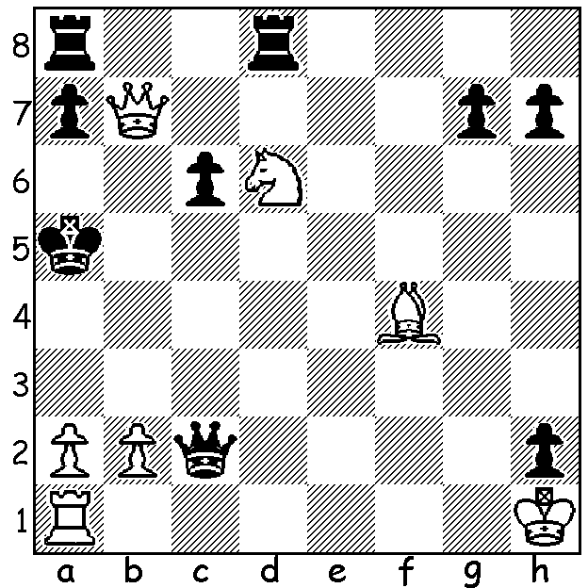
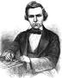
Paul Morphy vs Theodor Lichtenhein 1857:
White to play and win:

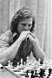
CHESS AND MENTAL HEALTH
While Chess has been claimed to improve brain function, memory, cognitive skills, strategic thinking and attention and has been used as a mental health therapy, there are a number of examples of leading chess players, obsessed with the game, suffering mental breakdowns. Last week's subject, Tony Miles, is one example with Miles, who had ambitions to be world champion, suffering a breakdown and being institutionalised for a short period. He believed a rival, Raymond Keene, had plans to have him murdered and it seems losing his ranking as UK number 1 to Nigel Short and a short match drubbing from Garry Kasparov, together with marital problems, combined to send him over the edge.
Two quotes I've come across: 'Poets do not go mad, chess players do' (English writer G K Chesterton) and 'No chess grandmaster is normal. Tony Miles
They only differ in the extent of their madness' (Viktor Korchnoi, twice challenger for world title).
The first great player to go insane was Paul Morphy (1837-1884) who spent years unsuccessfully trying to arrange a match with a reluctant Howard Staunton who claimed to be world champion. A thwarted Morphy retired from chess to pursue a career as a lawyer but suffered delusions of persecution, spent the final decade of his life wandering the streets of New Orleans and died penniless.

SOLUTION: 1.Bd2+! if 1...Qxd2 2.Nc4+ Ka4 3.Qb3# or b3#: if 1...Kh4 Qa6#.

