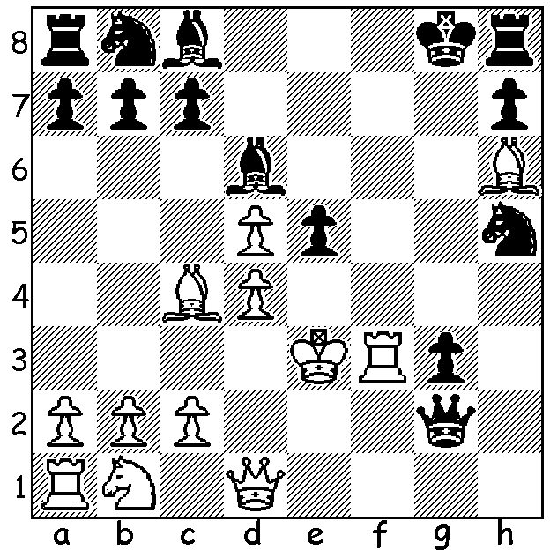

Wilhelm Steinitz vs Paul Wilson 1862:
White to play and mate in 4:

CHESS AND MENTAL HEALTH II

This week's column continues a look at the connection between outstanding chess players and insanity. Scientists have found a fine line between genius and madness as they share the same genes. And psychologists have discovered that exceptionally creative people have a gene that is linked to psychosis and depression. We could hardly find a better example than that of Wilhelm Steinitz, world champion 1886-1894. After being dethroned by Emanuel Lasker he travelled to Russia where he suffered a mental breakdown and was confined to a sanitorium. He recovered and continued to play but on his return to USA he suffered a relapse and was again institutionised. He is reported to have claimed that he had played against God and had won. He, like Morphy, died a pauper.

Another more recent example is Raymond Weinstein, born 1941, a near contemporary of Bobby Fischer. He was US Junior champion in 1958 and a member of the first US team to win the World Student Team Championships in 1960 where he won a gold medal for top score on his board. Again in 1960 he played in the US Olympiad team and was third in 1960-61 US Championship which qualified him to compete in the World Championship Interzonal. However later in 1961, aged 22, he was arrested for assaulting a chess writer in Amsterdam and deported back to USA. While in a halfway house he slit the throat of a fellow resident and stood trial for murder. He was deemed insane and comitted to detention in a psychiatric centre and, I believe, remains there today.

SOLUTION: 1.Rf8+! Bxf8 2.d6+ Qd5 3.Bxd5#.

