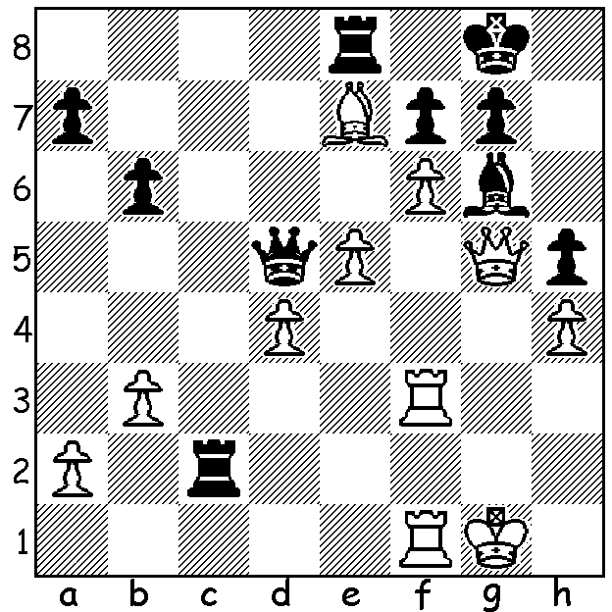
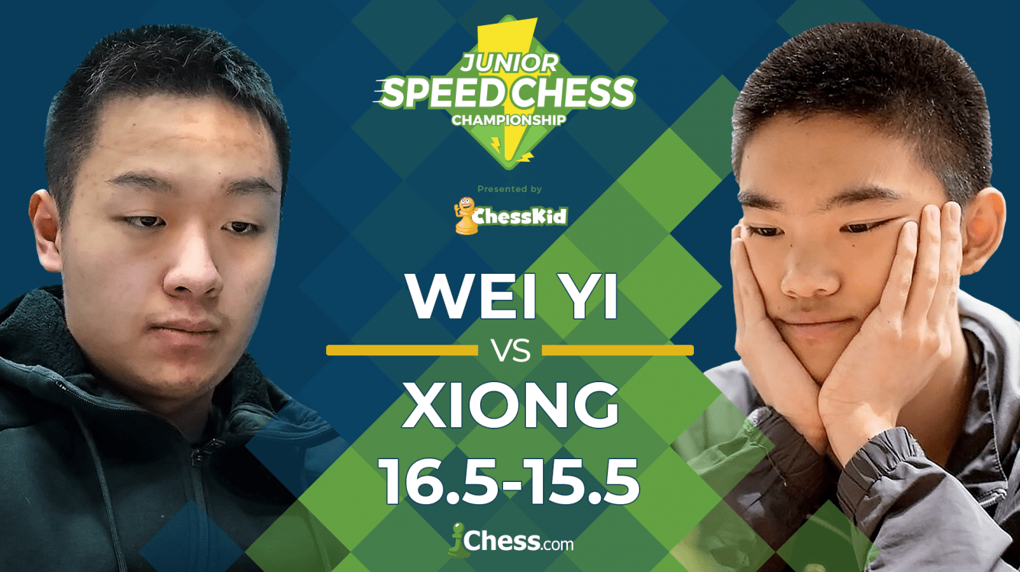
Wei Yi vs Jeffrey Xiong Wei Yi and Jeffrey Xiong
2019 Internet Junior Speed Chess Final
Black's centrally placed queen, domination of the open file and more secure king
give him an advantage but White can force Black to take a draw: how (4 moves)?

JUNIOR SPEED CHESS

Between mid May and August chess.com ran an on-line knock-out Junior Speed Chess Champion- ship with 34 of the world's top juniors competing. The format featured 90 mins of 5min + 1sec Blitz, 60min of 3min + 1sec Blitz and 30min of 1min + 1sec Bullet chess. Winner was Wei Yi (China) who defeated Jeffrey Xiong (USA) in a hard fought and exciting final in which the players were tied on 16 points each after four additional bullet games before Wei Yi drew an Armegeddon decider to take the title (in the Armegeddon White had 5min to Black's 3min - no increments with White having to win).
Australia had a representative in Anton Smirnov (pictured) who was beaten 10-19 by Xiong despite
winning the 5min section.

2019 WILLETTON OPEN
The Willetton Open, a WA Grand Prix event played 17/18 August, was won by Kuan Han Sen who won all his six games. Equal second on 4/6 were Ben Dagza, Andador Diminador and Jamie Laubbacher who took out top place in the Under 1700 group. Equal second Under 1700 were Marco Gunawan and Dylan Gough with 3.5.

SOLUTION: White played 1.Rf4 defending the d pawn but lost. He missed 1.Qxg6!! Qxd4+ (a vital zwischenzug) 2.R3f2 fxg6 3.f7+ Kh7 4.fxe8=Q Qg4+ with a perpetual.

