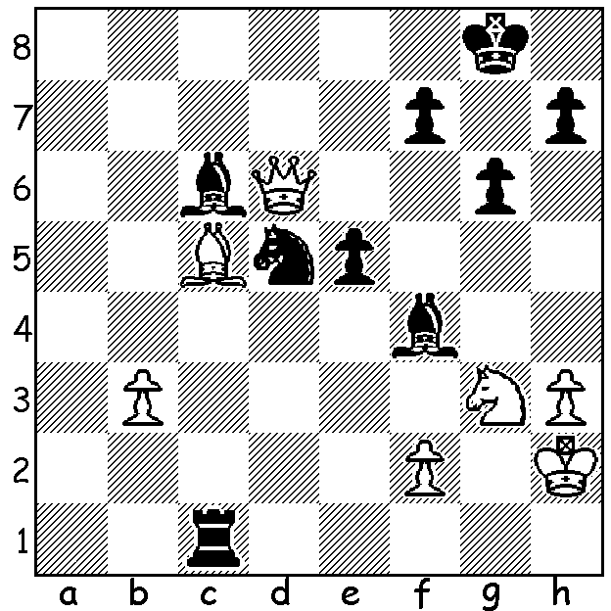
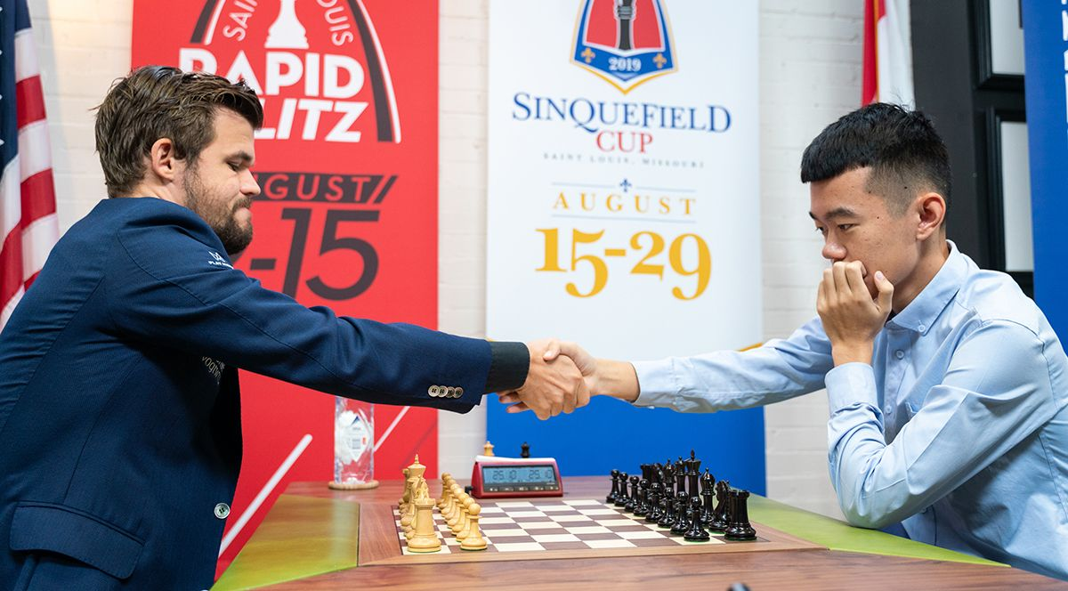
Magnus Carlsen vs Ding Liren: in this cut and thrust game, Carlsen has queen for rook, bishop and pawn and with his last move, Bc5, threatens mate and the unprotected bishop; however it's Black who wins. Can you see how?

WORLD CHAMPION LOSES HIS FIRST PAY-OFF SINCE 2007

The Sinquefield Cup, played last month in St Louis, USA, produced an abundance of draws with five of the 12 players unbeaten with Ian Nepomniachtchi the only player to win three of his eleven games, while four players failed to win a game. World champion Magnus Carlsen drew his first nine games before winning his final two to come equal first with Ding Liren on 6.5/11. Other scores: Sergey Karjakin and Vishy Anand 6, Nepomniachtchi, Shakhiyar Mamedyarov (who drew all 11 games), Fabiano Caruana and Anish Giri all 5.5, Hikaru Nakamura and Maxine Vachier-Lagrave 5, Levon Aronian and Wesley So 4.5. The play-off between Carlsen and Ding produced two Rapidplay draws (25min + 10sec) before Ding won the two Blitz games (5min + 3sec), the second of which produced a brilliant finish (see today's puzzle) and which some have dubbed 'The Immortal Blitz Game'. Carlsen's loss of the play-off was his first since 2007 with two of his successful play-offs being in world championship matches against Karjakin and Caruana.

SOLUTION: 1...Ne7 (a brilliant clearance sacrifice, protecting the c6 bishop and opening the a8-h1 diagonal): White resigns (2.Qxe7 Rh1#).

