(due to non publication in the West Australian on 7th September
this article was re-submitted for 21st September)
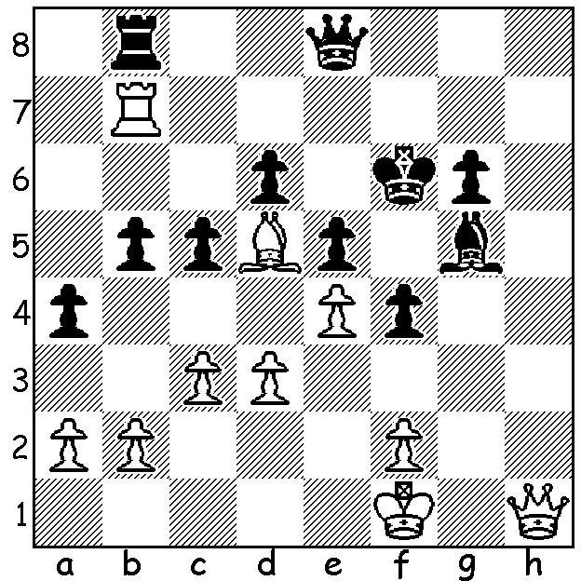
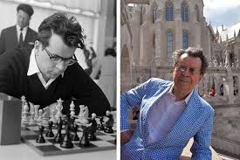
Pal Benko vs Erno Gereben (Budapest 1954):
Benko, in a game before his defection to USA, wins quickly.

PAL BENKO 1928 - 2019

Late last month the death was announced of US grandmaster Pal Benko at the age of 91. In this article I shall be tracing the life of Benko from birth to his settling in USA while next week will be on his life in USA. He was born in Amiens while his Hungarian parents were travelling in France. He spent most of his childhood in Hungary and learnt the game from his father when ten. He had a happy childhood but World War II brought disaster to him and his family. He was conscripted to the army but deserted. However when he reached home he discovered his father and brother had both been incarcerated as prisoners of war despite neither being in the army. His father was released after 18 months (during this time Pal's mother had died) and defected to USA. Pal, who had won the Hungarian Championship aged 20 and become the second best player in Hungary after Lazslo Szabo, also tried to defect but was captured and spent a year and a half in a concentration camp in appalling conditions, being released only after the death of Stalin. In 1958 he did succeed in defecting while playing in the World Student Team Championship in Reyjkavik, Iceland. Because the quota of 30,000 for Hungarian refugees had been reached he had to use his French passport and missed out on the benefits afforded to others.

SOLUTION: 1.Qh8+! Qxh8 2.Rf7#.

