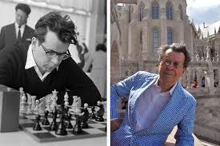
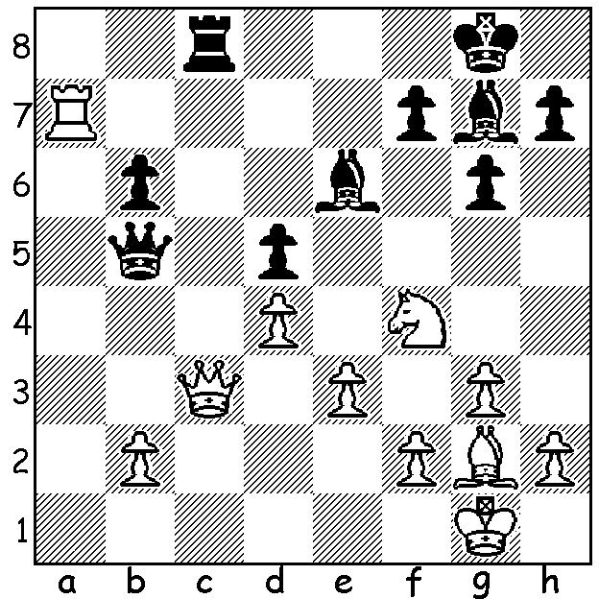

Pal Benko vs William Martz 1973
White to play and win.

PAL BENKO 1928 - 2019 (Part II)
Today we follow the career of recently deceased Pal Benko after he gained political asylum in the USA in 1958. His greatest successes were in the US Open which he won a record 8 times. He represented the US in 6 Olympiads (+ one for Hungary). He qualified for three Candidate Tournaments (to decide a challenger to the world champion) but voluntarily gave up his place in the third, 1970, to Bobby Fischer, a momentous decision as it paved the way for Fischer to become world champion in 1972. He had victories over four world champions, Smyslov, Petrosian, Tal and Fischer. He coached the Polgar sisters and Peter Leko, a one-time youngest GM. He was a noted endgame theorist and endgame composer and also contributed to opening theory with 1.g3 (called the Benko Opening) and 1.d4 Nf6 2.c4 c5 3.d5 b5, the Benko Gambit (also known as the Volga Gambit).

WA JUNIOR RAPIDPLAY CHAMPIONSHIPS
These will be held Mon 7 & Tues 8 October at Leeming Primary with two sections, Under 18 & Under 12 (although there will be prizes for 5 age groups). See cawa.org.au for full details and entry.

SOLUTION: 1.Nxe6! (destroying the guard) Rxc3 2.Ra8+ mating in 3 (the vulnerable back rank).

