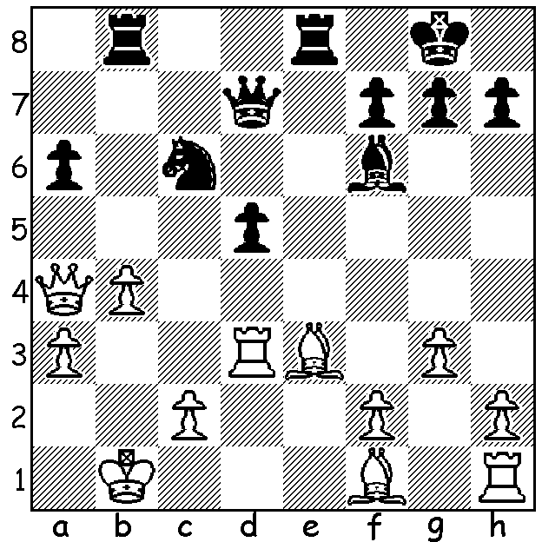
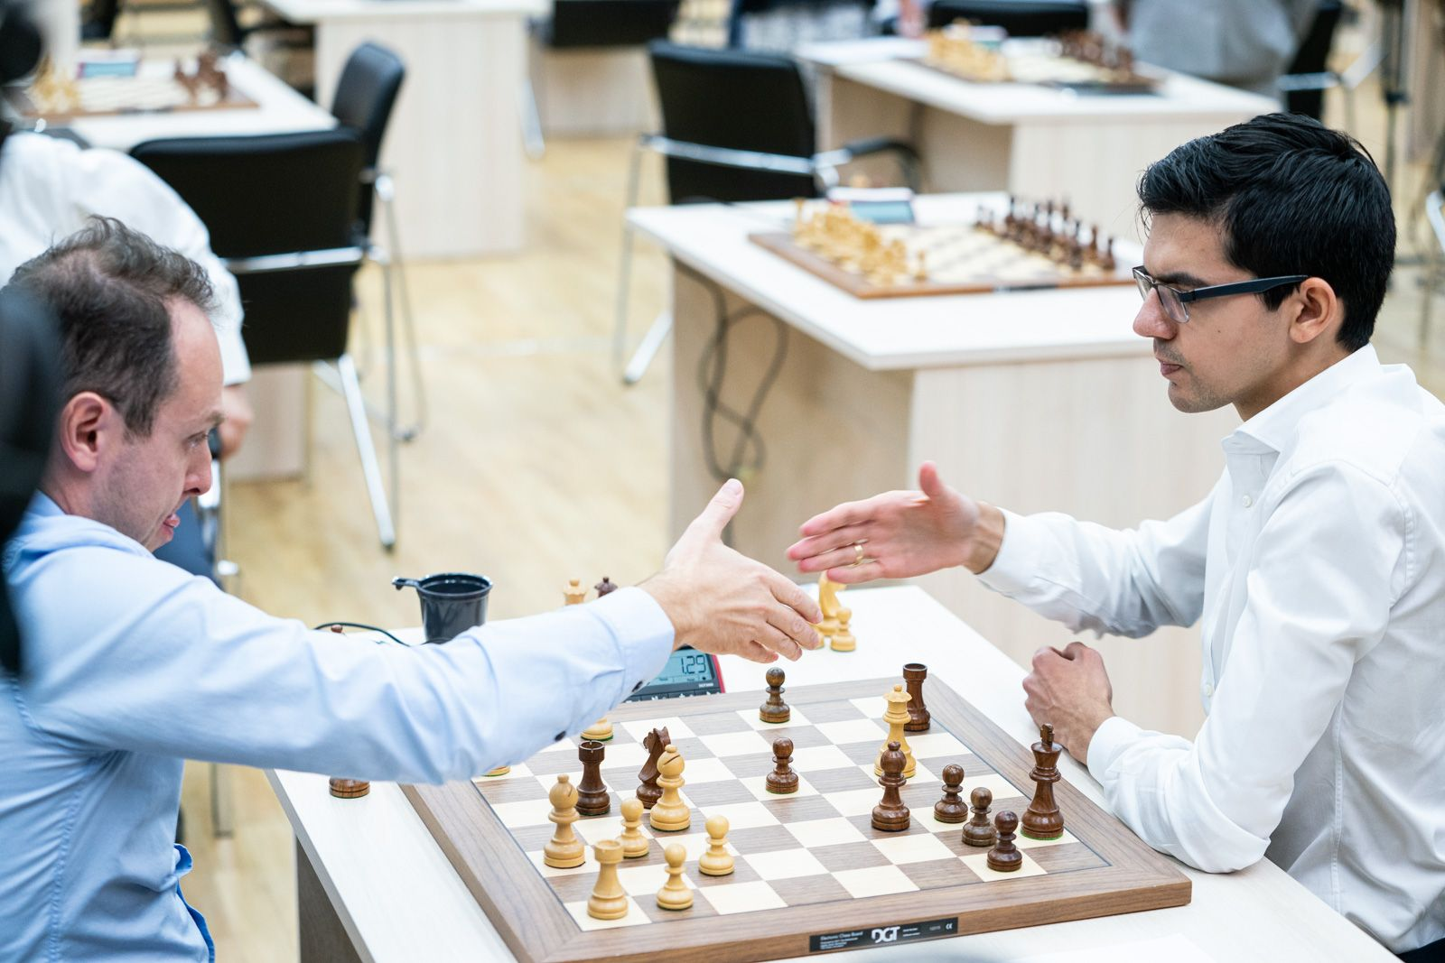
Anish Giri vs Evgenyi Najer Najer resigning vs Giri

2019 World Cup, Rd 2, Game 9 (Armegeddon):
Starting with only four minutes on his clock (+ 2 sec increments), Black
brings off a brilliant finish wih every surviving piece contributing (8 moves):

2019 WORLD CUP

At time of writing the Chess World Cup, taking place in Khanty-Mansyisk, Russia, has reached the final stage with just two competitors remaining from the initial 128. The format of this seven round Knock-Out involves two classic games (90min/40 moves + 30min with 30sec increments) followed by, if necessary, two rapidplay (25min + 10sec increment), two more rapidplay (again if needed) of 10min + 10sec and finally two blitz (5min + 3sec) with the provision to play an Armegeddon game to finally decide the tie (White with 5min + 2sec must win while Black with 4min + 2sec can draw to advance). Total prize fund is US$1,600,000 with first prize $110,000 while the two finalists gain qualification to the next Candidates, the winner of which gains the right to challenge Magnus Carlsen for the world title. Australian Shaun Press, representing PNG, (Australian qualifier Max Illingworth had retired) had the privilege (?) of playing the leading Chinese player and top
seed Ding Liren in Rd 1. There has been only one Armegeddon game, with Anish Giri winning his Rd 2 tie 5-4 (see diagram), while five ties have required eight games to find a winner.

WA JUNIOR RAPIDPLAY CHAMPIONSHIPS

These will be held Mon 7 & Tues 8 October at Leeming Primary with two sections, Under 18 & Under 12 (although there will be prizes for 5 age groups). See cawa.org.au for full details and entry.

SOLUTION: 1...Nxb4!! 2.Qxd7 Nxd3+ (the first of a number of discovered checks) 3.Ka2 Rb2+ 4.Ka1 Rxc2+ 5.Kb1 Rb2+ 6.Ka1 Rd2+ (the seesaw has set up mate) 7.Kb1 Rb8+ White resigns.

