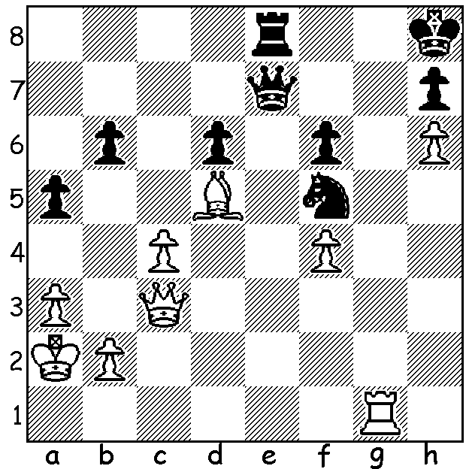
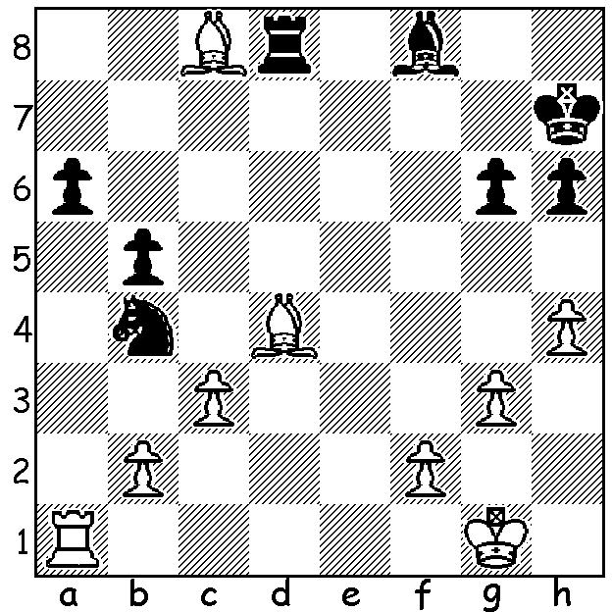
Diagram 1: Ding - Radjabov Diagram 2: Radjabov - Ding
2019 World Cup, Final, Game 2: Final, Game 3:

1.White has just played 1.h6. How would White win after 1...Nxh6. Black played 1.Ne6 to eliminate the raking bishop but resigned after White's next. Can you find the killer move?
2. Black played 1...Rxc8 but lost. Can you find a better defence?

2019 WORLD CUP
From a starting field of 128 in Khanty-Mansiysk, Russia, four contestants were left at the end with top seed Ding Liren facing Teimour Radjabov for first place and defeated semi-finalists Maxime Vachier-Lagrave and Yu Yangyi playing off for third place. Ding won the second Classic game with his Azerbaijani rival winning the third (draws 1&4). Four Rapidplay draws followed before Radjabov won the two Blitz games to win 6-4. MVL and Yu Yangi played four Classic games before the Frenchman won two successive Rapidplay to gain third place 4-2.

SOLUTION: Diag 1: 1...Nxb4!! 2.Qxd7 Nxd3+ (the first of a number of discovered checks) 3.Ka2 Rb2+ 4.Ka1 Rxc2+ 5.Kb1 Rb2+ 6.Ka1 Rd2+ (the seesaw has set up mate) 7.Kb1 Rb8+ White resigns.
Diag 2: 1...Nc2, ensuring bishops of opposite colours, should draw (2.Rc1 Nxd4 3.Rc1 Nxd4 4.cxd4 a5 or ...Rxd4 5.Bxa6 Rb4).

