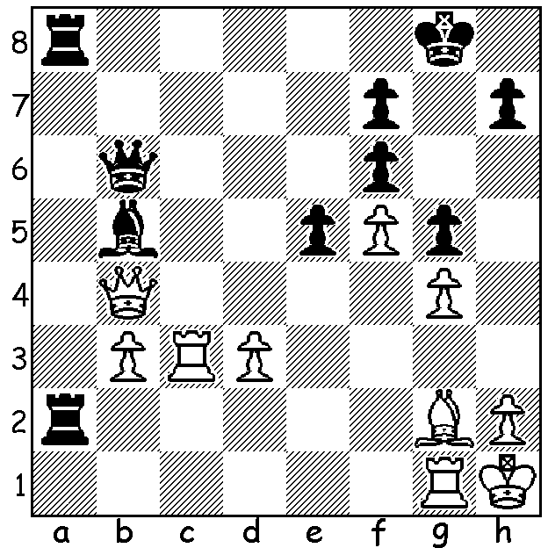
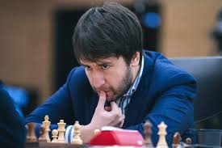
Rustam Kasimdzhanov - Teimour Radjabov 2014: Radjabov at World Cup
Black to play and win (2 variations 3/5 moves):

Last week I reported on Teimour Radjabov defeating Ding Liren in the final of the World Cup and I can imagine readers wondering who Teimour Radjabov is as he appears to have been absent from many of the leading tournaments for a number of years. Born in Azerbaijan in 1987 and becoming a Grandmaster at the age of 14, he gained fame when he defeated Garry Kasparov in the 2003 Linares tournament aged 15. He reached his peak rating of 2793 in 2012 when he was ranked four in the world. He confesses that his interest in chess had waned and he had considered giving the game up a number of times. Now having qualified for the 2020 Candidates (to find a challenger to the world champion) it seems his enthusiasm will have been rekindled.


By now young West Australian Temur Kuybokarov will
be playing in the World Under 20 World Championship in
Delhi. Originally from Uzbekistan, Temur has had outstanding
success since competing in Australia, having won the Australian
Open in both 2017 and 2019 and is currently ranked three in
Australia. He was awarded the title of Grandmaster this year.
An appeal has been launched by CAWA to give financial support
and all members are asked to make a donation, however small,
to help raise $5000 towards his costs (see cawa.org.au).

SOLUTION: I hope you noticed the White queen was
unprotected allowing 1...Rxg2! if 2.Rxg2 Ra1+ 3.Rg1
Bc6+ 4.Rxc6 Rxg1+! 5.Kxg1 Qxb4 or 1...Kxg2 2.Bc6+ etc. Temur Kuybokarov

