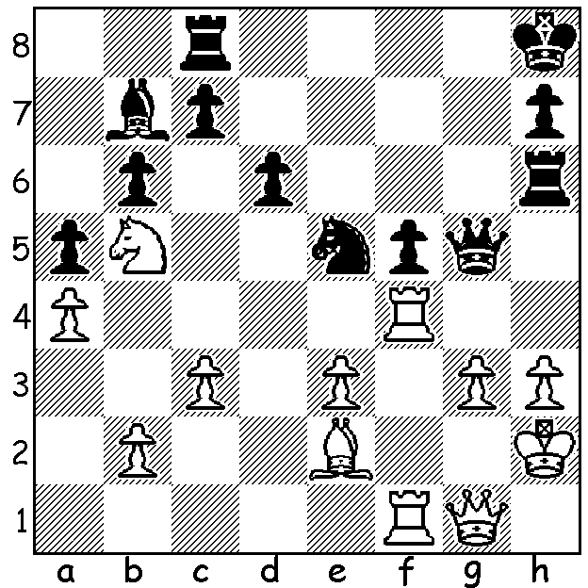
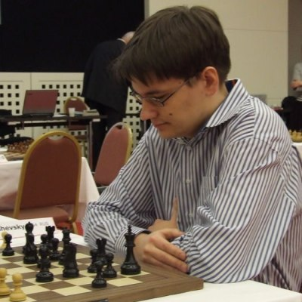
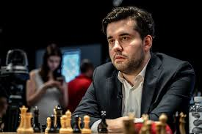
Another position from the recent World Cup,
Evgeny Tomashevesky (left) - Ian Nepomniachtchi (right), Rd 3, Game 8:
After Black's last move 1...Rh6 White played 2.Rxf5? allowing Black a
spectacular win (try to find White's desperate attempt to avoid mate).

HOW TO LOSE WEIGHT WHILE BARELY MOVING
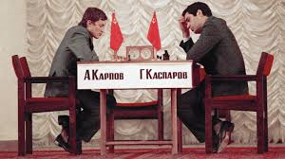
This was the heading of an article I had been directed to regarding the stress of Grandmaster chess where titles, qualifications, rating points and money are all involved. Mental effort and stress, which goes side by side with serious competition, cause heart rates to increase, force the body to produce more energy, all magnified by disturbed sleep patterns
common to most players during tournaments. The
1984-85 world championship match between Anatoly
Karpov and Garry Kasparov was aborted after 48
games with defending champion Karpov looking
haggard after losing 10kg during the exhausting
match. In a future article I shall detail how the top
GMs try to be fit to face the rigours of tournament
and match play. Karpov v Kasparov

WORLD UNDER 20 CHAMPIONSHIP
West Australian Temur Kuybokarov, seeded 18th and one of the 15 GMs in a field of 93 at the World Under 20 Championship in Delhi, was up to =12th place after 8 rounds with 5pts (+3 =4 -1). An appeal has been launched by CAWA to give financial support and all members are asked to make a donation, however small, to help raise $5000 towards his costs (see cawa.org.au).

KINGSLEY OPEN
The Kingsley Open (penultimate WA GP event of 2019) will be held at N Woodvale Primary on Sat 9 & Sun 10 November. For enquiries or entries see cawa.org.au or contact me 0439798607.

SOLUTION: 1...Qg4!! Now if 3.Bxg4 Nxg4# or 3.h4, not 3...Qxe2+, but 3...Rxh4+! 4.gxh4 Qxh4#. White tried 2.Rf8+ but after 2...Rxf8 3.Rxf8+ Kg7 4.Rf7+! Kxf7 5.Qf1+ Nf3+ White resigned.

