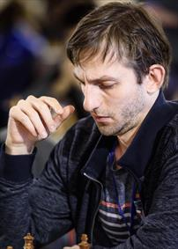
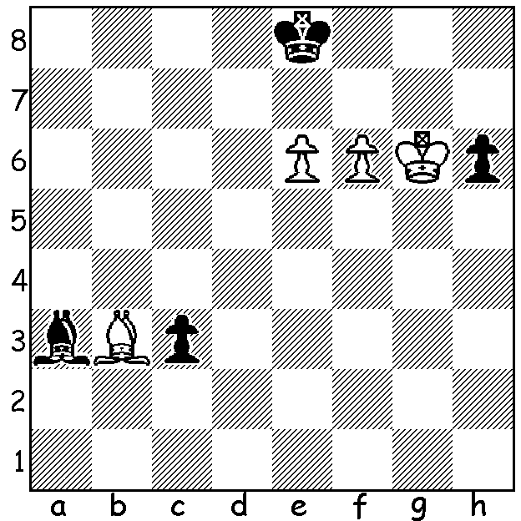
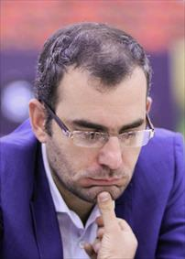
A variation from Alexander Grischuk (left) vs Leiner Dominguez (World Cup 2019): if Black moves his bishop back and forth a3-b4 can you plan to win as White? However Black has a surprising immediate drawing move.

FITNESS REGIMES OF LEADING GMs
Following up from last week's article on the energy expended by the leading GMs, here are details of the fitness regimes of some of them:
In preparation for a big tournament world number 2 Fabiano Caruana's fitness schedule might well include a 10km run, an hour of tennis and at least an hour of swimming.
Former world champion Vishy Anand, who at 49 is still able to compete in the elite events, does two hours of cardio each night to tire himself out to ensure a good night's sleep. He also takes long walks, cycles and swims. Before his 2013 world championship match with Carlsen he went on a diet to lose weight despite food being a particular pleasure.
World champion Magnus Carlsen has perfected his fitness routine working for hours pre-tournament, running on the treadmill, practising yoga, playing soccer with friends and has also been skiing. He has a personal chef to ensure he's eating the right food, chews gum during games to increase brain function and taps his legs rhythically to keep his brain and body alert between moves.
Many players will cut out alcohol completely before and during events, a far cry from Alexander Alekhine, whose alcoholism contributed to losing the world championship in 1935 to Max Euwe (he regained the title the following year after getting off the grog).

WORLD UNDER 20 CHAMPIONSHIP
West Australian Temur Kuybokarov, seeded 18th and one of the 15 GMs in a field of 93 at the World Under 20 Championship in Delhi, finished with 7/11 (+4 =6 -1) to share 9th place. Winner was Evgeny Shtembuliak (Ukraine) with 9/11 while Australia's other representative, Albert Winkerman, scored 5.5.

KINGSLEY OPEN
The Kingsley Open (penultimate WA GP event of 2019) will be held at N Woodvale Primary on Sat 9 & Sun 10 November. For enquiries or entries see cawa.org.au or contact me 0439798607.

SOLUTION: If 1...Bb4 or 1...h5 White will capture the h pawn and trek over to c7, play Ba4+ followed by Kd8 ensuring a queen promotion. However Black can play 1...Be7!! (2.fxe7 Kxe7 followed by Kxe6 after deflecting both king and bishop by advancing his h pawn and then his c pawn.If 2.f7+ Black has achieved a drawing blockade).

