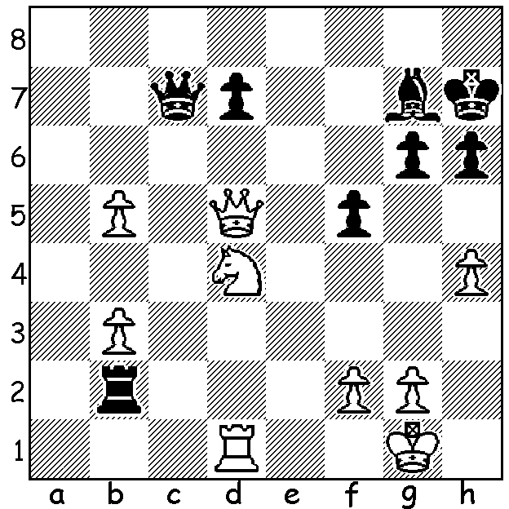

Alon Greenfeld vs Judit Polgar 1989:
Black to play and win (4 moves):

SUPER GIRLS

The position above was won by the world's strongest
ever female player, Judit Polgar, when she was 12
or 13. Born in July 1976, Judit became the then
youngest ever Grandmaster at 15 yr 4 mths, beating
the record of Bobby Fischer. She also became the
youngest ever player to break into the top 100 and
has been the only woman to have crossed the 2700
('super GM') barrier and was at one time ranked 8th
in the world.. Now retired she has beaten 11 players
who have been world champion, including Gary Carissa Yip

Kasparov and current champion Magnus Carlsen.

Just before her 11th birthday young American
Carissa Yip, with a win against Alexander Ivanov,
became the youngest girl to defeat a Grandmaster
and is now the top ranked US female.

WGM Jennifer Yu, born 2002, won this year's US
Womens Championship with the astounding 9/10
and already has all her necessary norms to receive
the IM title (International Master). Jennifer Yu

On the home front, 7 year old Elizabeth Williams has
recently won the Queensland Womens Championship
with 5/6 (+4 =2) and is, according to Ian Rogers, the
youngest ever state champion in Australia. Her interests
also include swimming and piano but she has found time
to compete in 11 tournaments already this year.

SOLUTION: 1...Rd2!! if 2.Rxd2 Qc1+ 3.Kh2 Qxd2
winning the knight.
Elizabeth Williams

