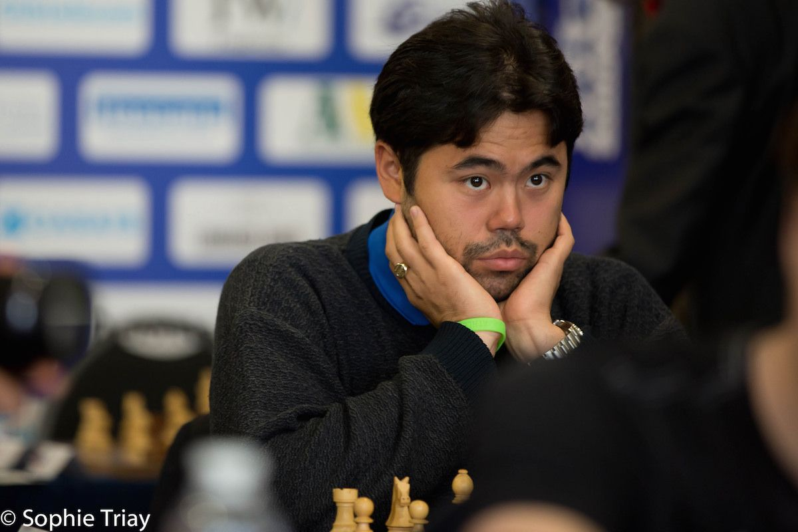
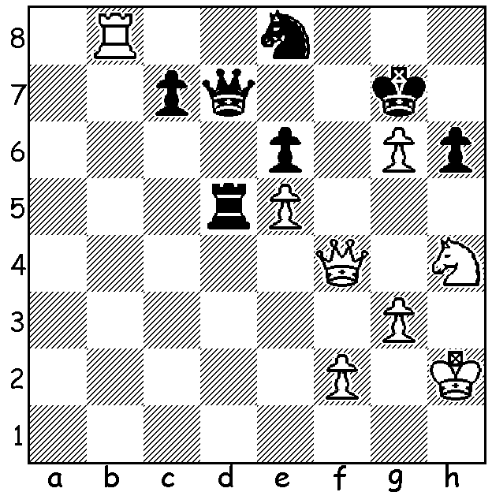
Hikaru Nakamura vs Hrant Melkumya Hikaru Nakamura
Isle of Man 2019):
White to play and win (2 variations):

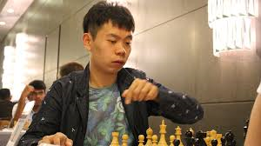
BOTTLENECK IN THE ISLE OF MAN
The aptly named Isle of Man Grand Open, played between 10th and 21st of October, had a large field
of 150 players with most of the world's top players competing with not only the inducement of a first
prize of US$70,000 but a place in the forthcoming Candidates tournament to decide on a challenger to world champion Magnus Carlsen. After 10 of the 11 rounds Fabiano Caruana led with 7.5 closely followed by a group of seven players on 7 which included Carlsen, Hikaru Nakamura and English hopeful David Wang Hao
Howell. In the final Carlsen and Caruana drew and only Wang Hao of the chasing group won after Howell made an elementary blunder in a game heading for a draw. The 30 year old Wang, who became the fourth Chinese player to break through the 'Super GM' ceiling of 2700, was awarded first place above Caruana on tie-break (having had the more difficult draw) and he joins his compatriot Ding Liren in the Candidates next year. Carlsen, Nakamura and Levon Aronian were three of the six players just behind on 7.5 with Carlsen taking an unbeaten run in classic chess to 101 games.

SOLUTION: 1.Rd8! Black resigns : if 1...Qxd8 2.Qf7+ Kh8 3.Qh7#: if 1...Qe7 2.Rxd5 exd5 3.Nf5+ wins the queen.

