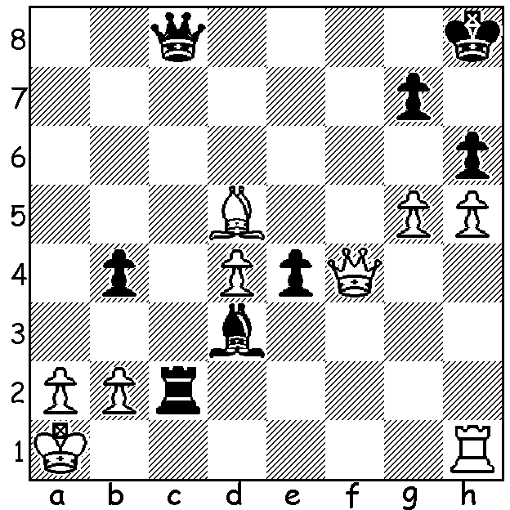

Gary Donaldson vs Ian McAteer
(Kingsley Open 2019):
With both sides' kings in danger
it's Black who gets in first:
Black to play and win
(6 moves longest variarion):

FEMALE FLAIR
The Kingsley Open (WA Grand Prix event, played 9-10 November) had a dissapointingly small field but it did include two former state champions and the current WA womens' champion. The final round's last two games to finish involved all four players vying for the top prizes. Ian McAteer brought off a spectacular finish to defeat Albany's Gary Donaldson (see diagram) while WFM Kathryn Hardegen secured a marathon win against junior Jamie Laubbacher with R + p vs R. Results: 1st Kathryn Hardegen 5/6, 2nd Ian McAteer 4.5: Under 1600 1st= Jamie Laubaccher and Gary Donaldson 3pts. An encouragement award went to eight year old Emily Zhang who won two of her six games. The final WA Grand Prix event will be the XMAS OPEN on Nov 30 / Dec 1.


AUSTRALIAN CHAMPIONSHIPS

Australian Championships,
Sydney, 2-13 January:
Australian Junior Championships,
Gold Coast 18-26 January.
Check websites if interested.

Kathryn Hardegen

SOLUTION: 1...Rxb2! and if 2.Kxb2 Qc3#. White can challenge the queen with 2.Rc1 but this will be met by 2...Rb1+! (deflection) 3.Rxb1 Qc3+ 4.Rb2 Qe1+ 5.Qc1 Qxc1+ 6.Rb1 Qxb1#. If 2.gxh6, 2.g6 or 2.Rf1 again Rb1+! or Rxa2+! White attempted to deflect the queen with 2.Bc6 (2...Qxc6?? 3.Qf8+) but this fails to 2...Rxa2+! 3.Kxa2 Qa6+ 4.Kb2 5.Qa3#. 2.Bc4 similarly fails to 2...Rxa2+! 3.Kxa2 Qa8+ or 3.Bxa2 Qc3# while 2.a4 is met by 2...Ra2+! Kxa2 (2.Bxa2 Qc3#) 2...Qc2+ 3.Ka1 Qc3+ 4.Ka2 Qa3#.

