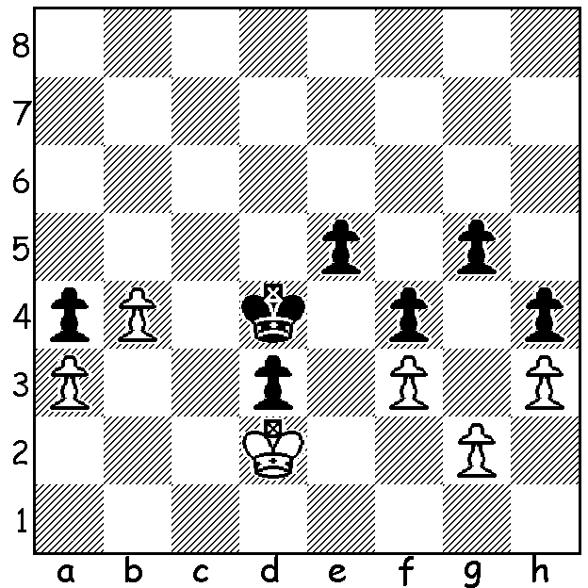

Anish Giri vs Magnus Carlsen Carlsen practising his soccer skills
(2019 Tata Steel Rapidplay)

Although a pawn down it may seem that White's protected passed b pawn, which prevents Black's king from advancing, will ensure a draw. However if 1.Kd1 Black has a text book winning line. Can you find it?

UNSTOPPABLE CARLSEN
The Grand Chess Tour features two classic and five rapid/blitz tournaments and is contested by the world's top 12 players plus 14 wild cards with the top four contestants playing semis and finals at the London Classic later this year. The Tata Steel Rapidplay/Blitz recently concluded in Kolkata, India, was the last event before the finals. The Rapidplay section was won in most convincing style by world champion Magnus Carlsen who won two and drew one game on each of the three days to score 15/18 with his rating performance for the event a staggering 3027. Second was Hikaru Nakamura, last year's GCT winner, with 11 and third Wesley So with 9. Next week a report on the blitz section.

AUSTRALIAN CHAMPIONSHIPS
Australian Championships, Sydney, 2-13 January:
Australian Junior Championships, Gold Coast 18-26 January.
Check websites if interested and for juniors inform CAWA of your intention to play as some financial and coaching assistance will be available.

SOLUTION: If 1.Kd1 e4 2.fxe g4! 3.hxg f3! 4.gxf h3 and queens. White instead played 1.b5 but lost with Black able to promote his a pawn.

