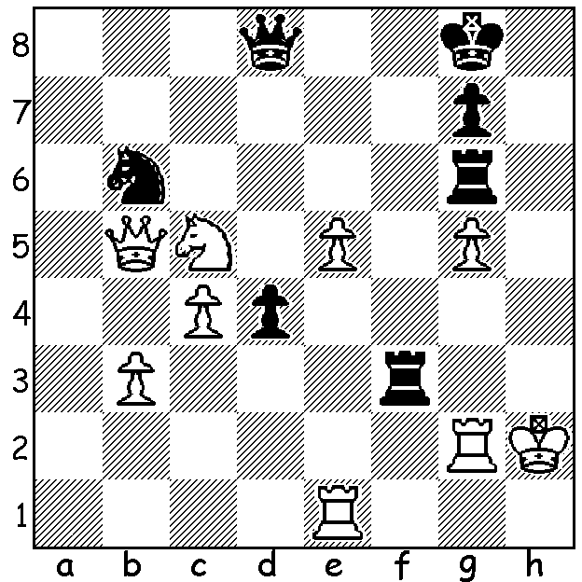
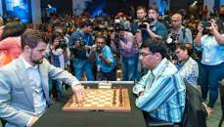
Magnus Carlsen vs Vishy Anand (2019 Tata Steel Blitz)
Black has a surprise move to turn round the game and qualify for the London finals.

VISHY MISSES TRIP TO LONDON
While it seemed almost certain world champion Magnus Carlsen would win the Tata Steel Rapidplay/Blitz in Kolkata, India, after scoring 15/18 in the rapidplay games (+6, =3, -0), the most important question was would former world champion and Indian hero Vishy Anand qualify for the 4-player Grand Chess Tour finals in London this month. Anand seemed on course to finish in the top six, which would guarantee a place at London, but lost a number of blitz games on the final day (5min + 3sec), including a loss on time when winning against Giri and a last round hectic time scramble against Carlsen (see diagram), and finished a disappointing 7th of the 10 players. This enabled Maxime Vachier-Lagrave, who was sitting out this event, having played all his entitled qualifying tournaments, to join Carlsen, Ding Liren and Levon Aronian (who finished last in Kolkata) in London. Carlsen finished with the record score of 26.5/36, losing only twice in his 27 games, both times to Ding. Hikaru Nakamura, who went through undefeated in the blitz, thus retaining his no.1 blitz ranking, finished second with 23.

CHRISTMAS OPEN
The Christmas Open, the final WA GP event for 2019, played last weekend, was won by Tristan Boyd with 6/6. Second was Ned Tomic 4/6, with rating prizes to junior Oscar Gao (3.5) and Gary Donaldson (3).
SOLUTION: If 1...Rh6+!! (brilliant deflection sactifice): if 2.gxh6 Qh4+ 3.Kg1 Qxe1+ 4.Kh2 Qxe5+ 5.Kg1 Qe3+ 6.Kh2 Rh3#. Declining the sacrifice with 2.Kg1 is met by 2...d3! threatening the winning 3...Qd4+ and if 4.Nd7 (an attempted obstruction sacrifice) 4... Re6 should win. Unfortunately for Vishy he missed this sacrifice in a time scramble and lost.

