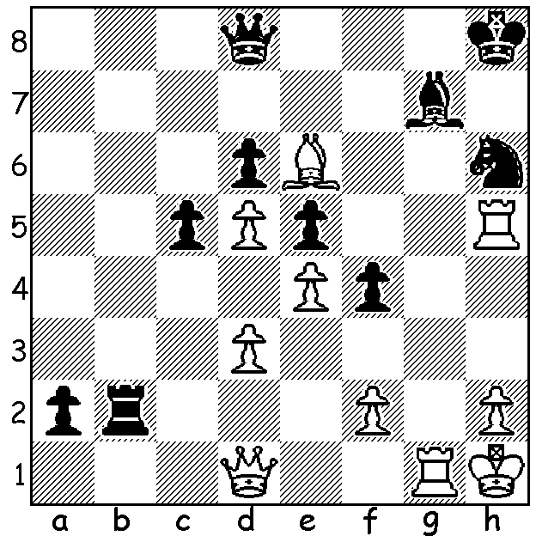
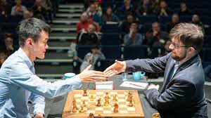
Ding Liren vs Maxime Vachier-Lagrave 2007: Ding vs MVL (London 2019)
Despite Black's threat of 1...Rb1 it's White
who wins. Can you see how?

GRAND CHESS TOUR FINALS
The primary event at the recent London Classic was the finals of the 2019 Grand Tour (a Grand Prix event almost exclusively for the top GMs) with semi-finals and finals at Classic (2 games, 6 pts a win), Rapidplay (2 games, 4 pts a win) and Blitz (4 games, 2 point a win). The semi finals pitted world champion Magnus Carlsen against Maxime Vachier-Lagrave and Ding Liren against Levon Aronian. Probably most people expected and wanted to see a Carlsen-Ding final, a possible foretaste of Carlsen's world championship defence next year. However it was MVL who progressed after defeating Carlsen. With all their Classic and Rapidplay games drawn and each player winning one of the four Blitz games MVL took the match with a win and draw in the two play-off Blitz games. Ding comfortably defeated Aronian 19 - 9 after draws in the two Classic games and victories in the two Rapidplay. In the play-off for third place Carlsen defeated Aronian after a draw in the fifth game (the first Blitz game) while Ding took the title and $150,000 by winning one and drawing one of both the Classic and Rapidplay to gain a winning lead of 15 - 5 leaving the Blitz games (which MVL won with three wins and a draw) inconsequential.

SOLUTION: 1.Rxg7!! Kxg7 2.Qg1+ Kf8 (2...Kh7 3.Bf5+ Kh8 4.Rxh6#) 3.Rf5+! Nxf5 4.Qg8+ Ke7 5.Qf7#. If Black ignores the sacrifice and plays 1...Rb1 the switchback 2.Rg1 wins - 2...Rxd1 3.Rxh6# (if 2... Qf8 3.Qg4 a1=Q 4.Rxh6+! Qxh6 5.Qg8#). Brilliant attacking play!

