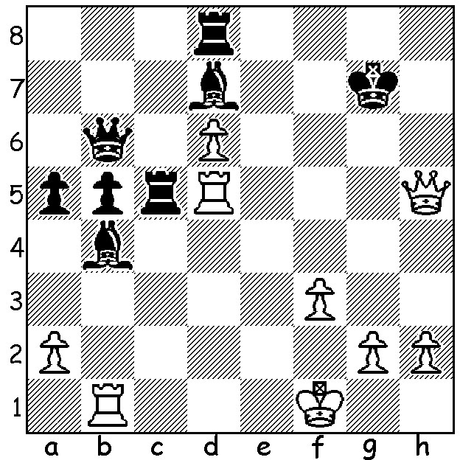

Anton Smirnov vs Evandro Amorim Barbosa
(Olympiad 2016)
White has sacrificed two pieces to expose Black's king.
How should he continue?

YOUNG WINNERS AT LONDON CLASSIC

As reported two weeks ago the London Classic FIDE Open with 166 competitors had two teenagers sharing the top score of 7.5/, Indian 14 year old Rameshbabu Praggnandhaa and 18 year old Australian Anton Smirnov. Today a little about these two outstanding young players.
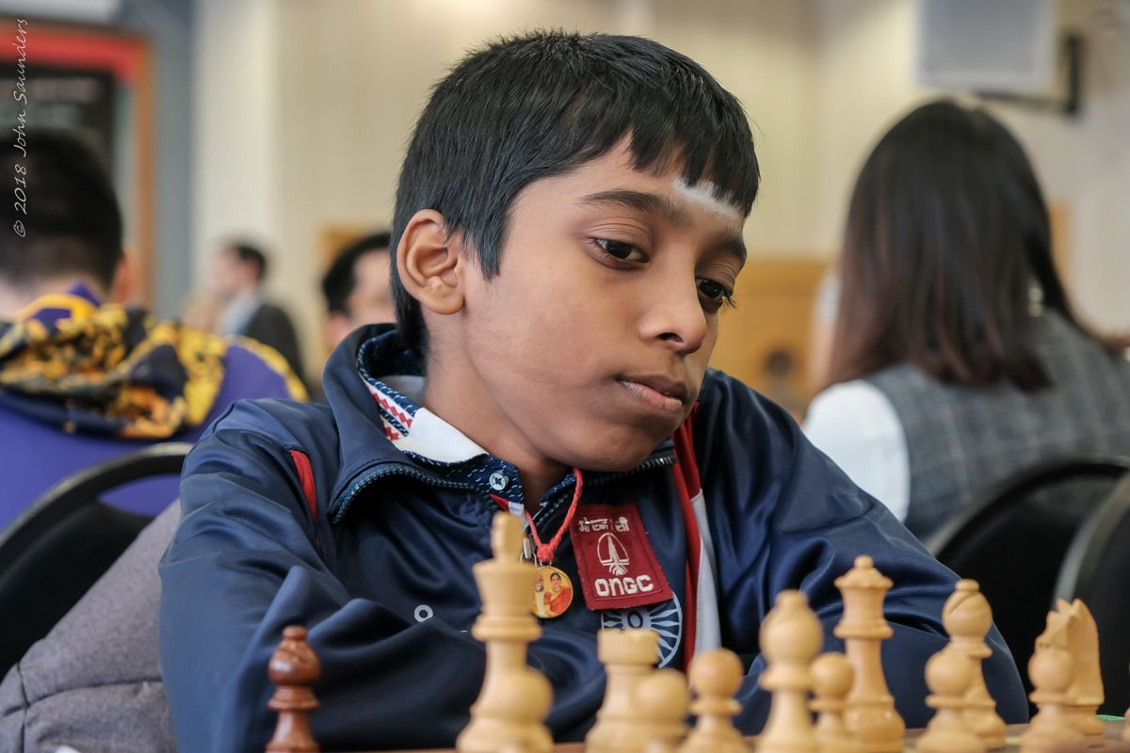
Pragg, as he is known, is the fourth youngest
player ever to achieve the title of Grandmaster,
Born in 2005 in Chennai, he won the World Youth
Championship Under 8 title in 2013 and the Under
10 title in 2015. In 2016 he became the youngest
ever International Master. This year he won the
World Youth Championship (Under 18) with 9/11
and also gained the GM title. His elder sister Vaishali
Womens Grandmaster.

Anton Smirnov, born in 2001, became a GM in 2017. He had gained the title of International Master in 2014 aged 13 (at the time the youngest ever). He was Australian Junior Champion in 2015 and won the Australasian Masters in 2018. He has been a regular in the Australian Olympiad side since 2014, being undefeated in both 2014 and 2016. His father Vladimir, originally from Russia and Anton's major coach, is an International Master.

SOLUTION: 1.Qg5+ (guarding c1) The game concluded 12...Kh7 (1...Kf7/8 are no better) 2.Rxb4! axb4 (2...Rc1+ 3.Qxc1 axb4 4.Rh5+ mates) 3.Rxc5 Be8 (to interpose on g6) 4.Qh4+ Kg7 5.Qd4+ resigns (the queen is lost to a discovered attack - 5.Kh6 6.Rh5+!).

