John Ellis vs Ricky Lopis (Australian Junior Championship 1996)
How should White continue?

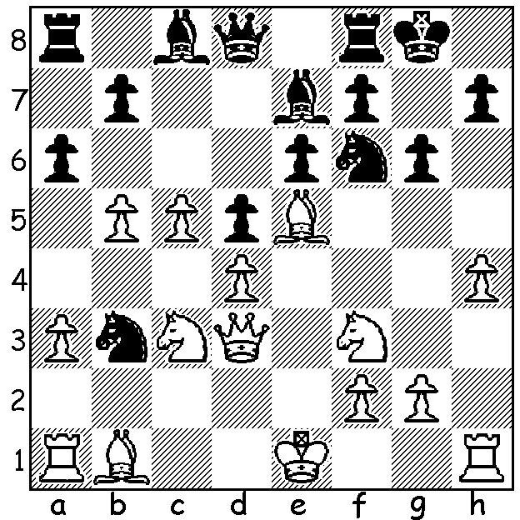


AUSTRALIAN JUNIOR CHAMPIONSHIPS
The Australian Junior Championships will be played on the Gold Coast January 18 to 26. West Australians have traditionally done well with recent wins of the Under 16 title by George Carolin-Unkovich and Patrick Gong. WA has also had runners-up in the Under 18 (eg Eu-Jin Teh and Craig Kinsman) but I believe the only WA winners of the Under 18 title were Mike Woodhams in 1966 and Arthur Pope in 1967. Looking through the list of winners we would come across a number of future Australian champions and Olympiad representatives but also names which have disappeared from the chess scene. In WA many of our most promising young players either give up chess to follow studies and then a career while others excel in some other competitive field (eg Chris Mulley, one of WA's top bridge players). I had high hopes that my son John would develop into a much better player than me but he has instead found his competitive challenge in Ultramarathon running. Now resident in Hong Kong, he has been competing in races over 100km throughout Asian countries, often in hot, humid and mountainous areas. After winning four of the races this year he gained the title of 2019 Asia Trail Masters Champion. We think of Chess as a long game but in Trail Running even a winner can take over 20 hours.

SOLUTION: If White moves the a1 rook Black could slow White's attack with 1...h5. Instead White ignore's Black's threat to open lines with 1.h5!! The game concluded 1...Nxa1 2.Ng5! (threat 3.hxg fxg 4.Nxh7! or 3...hxg 4.Bxf6 Bxf6 5.Qh3!) 2....Ng4 3.hxg Nxe5 4.Qh3! Nd3+ 5.Bxd3 Kg7 6.Qh6+ Kf6 7.Nh7#.

John Ellis - Ricky Lopis
Australian Junior Championship 1996, Rd 2
Caro-Kann, Botvinnik-Panov Attack
1.e4 c6 2.d4 d5 3.exd cxd 4.c4 Nf6 5.Nc3 Nc6 6.Nf3 e6
7.c5 Be7 8.Bf4 0-0 9.Nb5 Ne8 (better 9...Nh5) 10.Bd3 Nb4 11.Bb1 Qa5
12.Nc3 Nf6 13.a3 Nc6 14.b4! Qd8 (not 14...Nxb4? 15.axb4 Qxa1? 16.Bxh7+)
15.b5 Na5 16.Qd3 a6 17.Be5 g6 18.h4 Nb3 (see Diagram) 19.h5!! Nxa1
20.Ng5! Ng4 21.hxg Nxe5 22.Qh3! Nd3+ 23.Bxd3 Kg7 24.Qh6+ Kf6 25.Nxh7#.

Leading WA Scores:
=9th Eu Jin Teh 7/11
=14th Michael Wilkins (a future WA champions), Robbie Galvin, John Ellis, Sean Ong 6.5/11
(Ricky Lopis, ranked 3rd, was =3rd. In the Under10s Tristan Boyd came =1st with David Smerdon, a future Australian Olympiad Board, 1).

