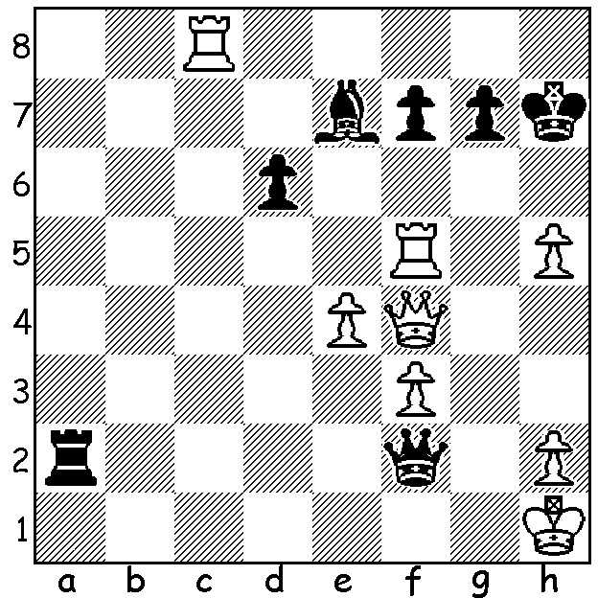

Magnus Carlsen vs Sergey Karjakin 2016:
Threatened with mate White gets in first:

2019 ANOTHER TRIUMPHAL YEAR FOR MAGNUS

Although Magnus Carlsen did not have to defend his World Championship title last year, he did win the World Rapidplay and World Blitz Championships. He won his third Rapidplay title in Moscow last month a point clear of his nearest rivals and followed up with victory in the Blitz for the fifth time defeating Hikaru Nakamura in a play-off. This is now the second time Carlsen has held all three titles. He is also the top ranked player in Classic and Rapidplay although Nakamura remains the top ranked player in Blitz.

One piece of eye-catching news from last year has been the emergence of 16 year old Iranian Alireza Firouzja and his banning by the Iranian authorities after playing against an Israeli opponent. It seems he is now likely to seekFrench nationality but competed under the FIDE flag in the World Rapidplay and Blitz where he was a joint runner-up in the Blitz and came so close to beating Carlsen. With three isolated pawns (two doubled) and bishop against lone bishop of opposite colour he accidently knocked over his king and lost on time putting it back up.

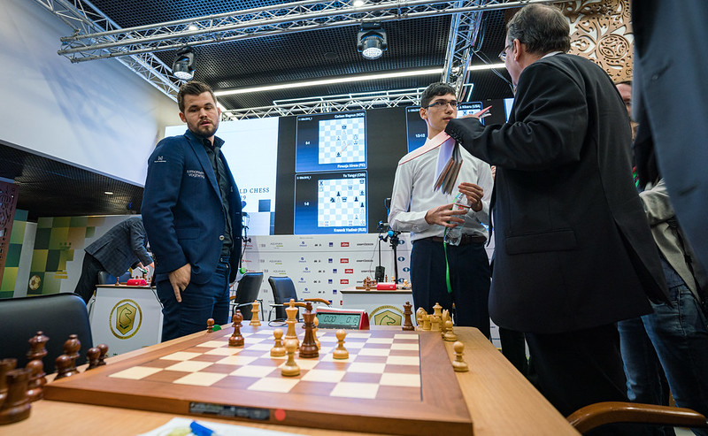
The chief arbiter explaining why Carlsen won (a mate can
be set up, eg WK on a1, WB on a2, BK on c2, BB on c3)

The new chess year has begun with a 97 move drawn game in the 12 Game Womens World Championship between champion Ju Wenjun and winner of the Womens Candidates Aleksandra Goryachenkina. This year will also see the Candidates playing for the right to challenge Carlsen for the world title and if I were a betting man my money would be on Ding Liren.

SOLUTION: 1.Qh6+!! (a startling deflection sacrifice of the queen); if 1...Kxh6 2.Rh8# and if 1...gxh6 2.Rxf7+.

