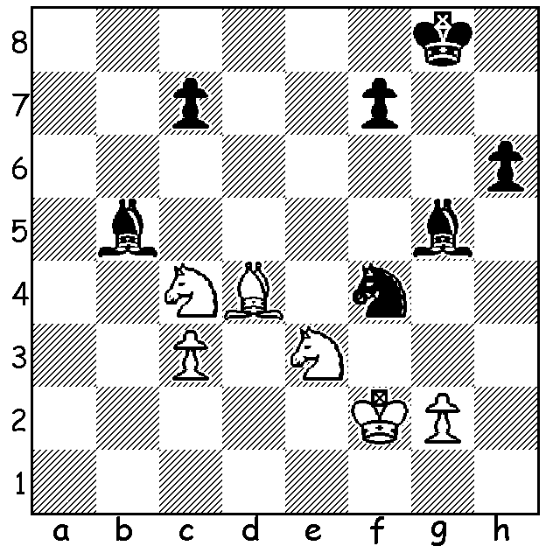

Cameron McGowan vs Temur Kuybokarov
(2020 Australian Championship):
Sometimes hours can be saved winning an endgame
by taking advantage of tactical opportunities: how
then does Black gain a certain winning advantage?

YOUNG WEST AUSTRALIAN WINS AUSTRALIAN CHAMPIONSHIP
Nineteen year old Temur Kuybokarov became the first West Australian player to win the Australian Chess Championship after scoring 9/11 in the 2020 championship in Sydney. After starting with 5 wins his lead was reduced with a Rd 6 loss but three more wins in succession left him needing only one point from his final two games which he accomplished with two draws. Winning his final five games to finish with 8/11 was second placed Junta Ikeda whom Temur had beaten in Rd 4.

Temur was born in Uzbekistan in 2000 and taught chess by his mother when aged five. Aged only 11 he defeated world champion Vishy Anand, although it was in a simultaneous display in which the world champion took on a number of players at the same time. Temur became a Grandmaster in 2019 after his family moved to Australia in 2018. He won the Australian Open, which alternates with the Australian Championship, in both 2017 and 2019. Last year he was acknowledged by the West Australian as one of the state's rising stars.




COMING EVENTS IN WA
CAWA has arranged with the State Library for chess sets and clocks to be available on 2nd Floor during opening hours for anyone to play.
Clubs have already reopened after the Christmas break with the Perth club having already started a two week Allegro. This will be followed by a rateable tournament divided into groups starting Wed Jan 30.
The Southern Suburbs start their annual Open Championship on Tuesday 4th February and the Metro Club commences its club championship on Thursday 6th February. Intending entrants to any of these events should ensure they nominate in time.

SOLUTION: 1...c5! wins a piece: 2.Bxc5 Nd3+ or 2.Be5 Nd3+ 3.Kf3 Bxe3. White played 2.Nd6 losing to 2...cxd4 3.Nxb5 dxe3 4.Kxe3 Nxg2+.

