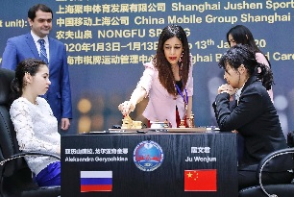
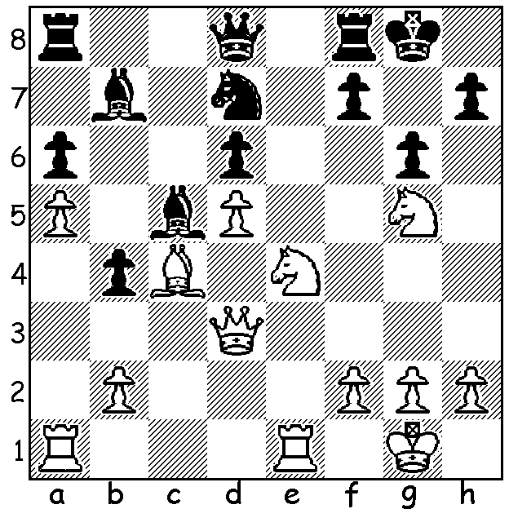
Aleksandra Goryachkina Womens World Championship 2020
vs Dina Drozdova 2012: (L to Rt) Aleksandra Goryachkina,
White to play and win (4 moves): Shohreh Bayar (referee), Ju Wenjun

CHESS vs the HIJAB
The Womens World Championship moved after six games from Shanghai to Vladivostok. With the score 3-3 (one win each) from the first half, Russian challenger Aleksandra Goryackina took the lead with a win in Game 8 against champion Ju Wenjun only for the champion to hit back with a wins in Game 9 and 10. However the main news event from the match has centred not on the players but on referee Shohreh Bayar. Bayar became the first woman to become General Secretary of a sports federation in Iran and is the sole female Category A International arbiter in Asia. Pictures have been published of her at the championship without the hijab, the compulsory scarf for Iranian women, and, fearing retribution, she has stated she will not return to Iran claiming 'people should have the right to choose the way they want to dress'.

This as far from the first incident of its kind. In 2017 Iranian WGM Dossa Derakhsami, aged 19, received a ban from Iranian authorities for not wearing a hijab while competing in Gibraltar. International women's events in Iran have also caused problems with US women's champion IM Nazi Paikidze-Barnes refusing to compete in the 2018 Womens World Champiuonship in Iran because of the stipulation that all contestants wear the hijab. Similarly Indian WGM Soumya Swaminathan, a former World Junior Girls Champion, then 19, refused to play in the 2018 Asian Nations Cup in Iran.

AUSTRALIAN JUNIOR CHAMPIONSHIPS
A number of WA juniors are taking part in the various age groups of the Australian Junior Championships in both Open and Girls' sections which are beilg played 18 - 26 of this month in the Gold Coast. We wish them good luck.

SOLUTION: 1.Qh3 h5 2.Qxd7! Qxd7 3.Nf6+ Kg7 4.Nxd7.

