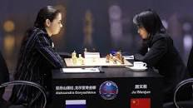
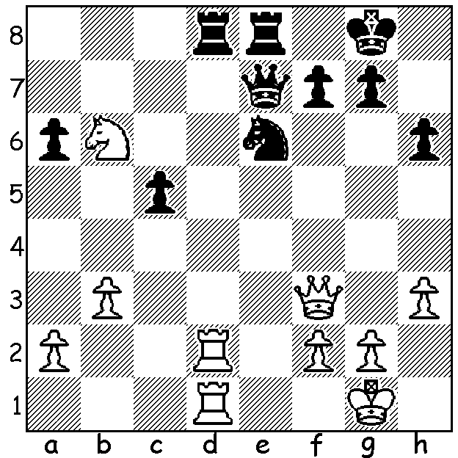

Sarasadat Khademalsharieh Womens World Championship
vs Ju Wenjun 2016: Goryachkina (L) vs Ju Wenju
Black wins material (5 moves)

WORLD CHAMPIONSHIP DECIDED IN TIEBREAKER
Last week I reported that in the Womens World Championship Ju Wenjun had taken a strong step to retaining the title against her Russian opponent Aleksandra Goryachkina by winning games 9 and 10 in the 12 game match to lead by a point. However after a draw in Game 11 Goryachkina in the final game tried the unusual 1.d4 d5 2.Nc3 and succeeded in winning and equalising the score. In the third of the four game rapidplay tiebreaker Ju Wenjun played the Reti (1.Nf3 2.g3), winning well and retaking the lead. Perhaps the challenger should again have tried something unusual in the 4th game but instead allowed the champion to simplify early with exchanges and secure the needed draw to retain her title 6-6, 2.5-1.5. It seemed throughout the match that the champion's better endgame play was the basic difference between two very evenly matched rivals, enabling her to hold, and one one case win, dificult endings. Ju Wenjun, 29 years, won the title in 2018, defeating her compatriot Tan Zhongyi 5.5-4.5 in a match and then again in 2018 retained the title defeating Kateryna Lagno (Russia, formerly Ukraine) 5-3 in the final of a 64 player knockout tournament.

AUSTRALIAN JUNIOR CHAMPIONSHIPS
Though small in numbers, WA players acquitted themselves well in the Australian Junior Championships at the Gold Coast. Rebo Yihe Fu (7/9) was second in the Under 14 (also =2nd in Open Blitz) and Emily Zhang was 3rd in the Under 10 Girls. Other scores: Under 16 - Jamie Labbacher 4/9; Under 14 - Kundan Dharmapuri 6/9; Under 12 - Iker Hernandez Mendez 5.5/9, Aanav Gupta 4.5/9. Under 12-18 Girls - Celine Ong 5/9 (3rd Under 14 Girls, also 1st Under 14 Girls Blitz, and 3rd Girls Problem Solving).

SOUTHERN SUBURBS OPEN will start February 4 at Leeming Primary. Details cawa.org.au

SOLUTION: 1...Nd4 2.Qh5 Nf3+! 3.Qxf3 Rxd2 4.Rxd2 Qd1+ 5.Kh2 Qxd2.

