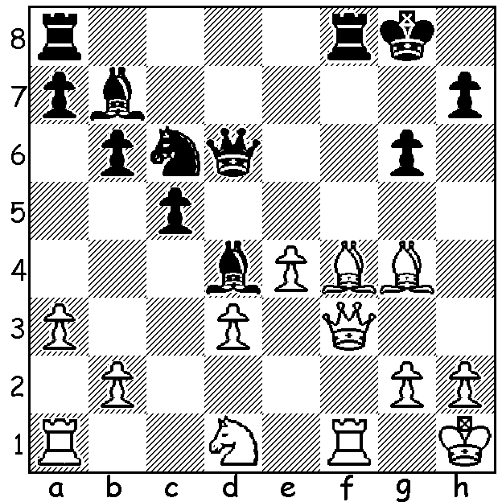


Alireza Firouzja Ettehadi vs Firouzja 2017:
Black to play and win (5 moves)

CHESS and POLITICS
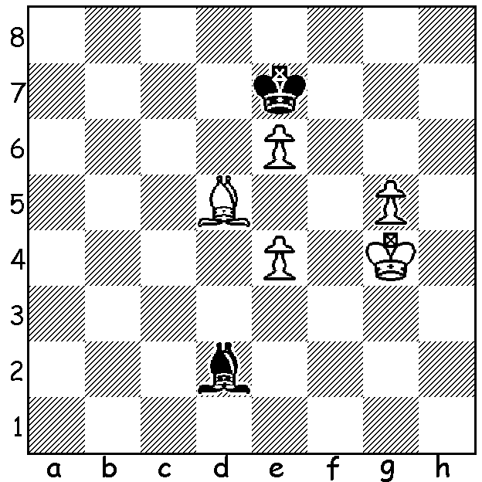
Two weeks ago I reported on how Iran was losing some of its strong female players (also internatioal arbiter Shohreh Bayat who refereed the recent Womens World Championship) over its demand that they wear the hijab. A second issue causing the country to lose players, both male and female, is its refusal to allow its players to compete against Israeli players. The strongest junior in the world, Alireza Firouza, announced last December that he would no longer play under the Iranian flag after Iran withdrew from the World Rapidplay and Blitz World Championships to uphold its ban on Iranians playing Israelis. Firouza, born June 2003 and now 16, learnt chess at eight. He became Iranian champion when only 12, a Grandmaster at 14 and, at 16 years one month, the second youngest to attain a rating of 2700. In 2018 in the World Blitz Championship he led with 6.5/7 before finishing with 12/21*. He won the 2019 European Fischer Random Championship with 8/9 and was runner-up in the 2019 World Rapidplay Championship with 10.5/15, a point behind world champion Magnus Carlsen.

* White vs Carlsen, Rd 19, he had the attached
position but inadvertently knocked over his king and
his flag fell while he was replacing it, giving the point
to Carlsen, since a mate is possible with the sole bishop.

The PERTH OPEN will be the first weekend Grand Prix
event of 2020. It will be held at the N Woodvle Primary
School on Saturday 15 and Sunday 16 Feb. Details and
entry cawa.org.au.

SOLUTION: With the White knight interferring with the rooks' inter-connection, White is susceptible to back row mating threats: 1...Be5! 2.g3 (2.Bxe5 Rxf3 3.Bxd6 Rxf1#) 2...g5 3.Bxe5 Nxe5 4.Qe2 (the queen is over-worked) 4...Rxf1+ 5.Qxf1 Nxg4.

