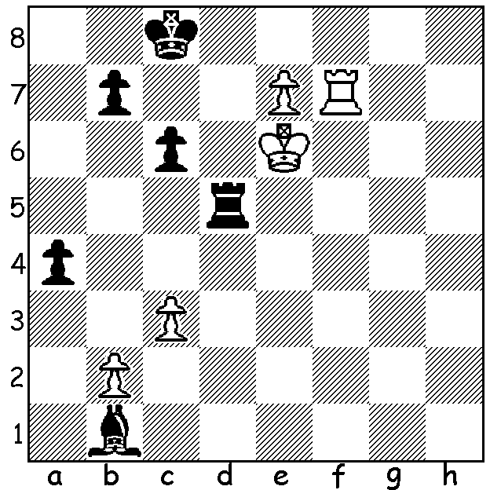
Lucas van Foreest vs Vincent Keymer, Tata Steel 2020:
it seems Black can find no way to prevent White from
queening (1...Rd8 2.Rf8). However he does find a way to
go into a slightly inferior ending which he was able to draw.


CHESS and POLITICS
Last week I wrote about the world's top junior Alireza Firouzja who has left Iran after the authorities withdrew the Iranian team due to play in the World Rapidplay and Blitz World Championships to uphold its ban on Iranians playing against Israeli players. He has since played under the FIDE flag but it's thought he will apply for French citizenship. He made a great impression in the 2020 Tata Steel Masters played last month in Wyk aan Zee. At about the half way mark he was in first place before successive losses to Carlsen, Caruana and Anand saw him slip to midway, finishing with 6.5/13.

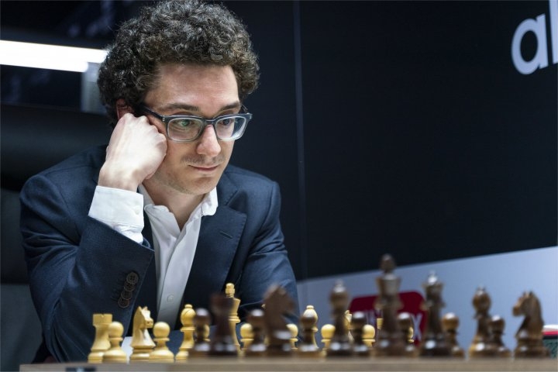
The tournament was won convincingly by Fabiano
Caruana with 10/13 (+7 =6), two points ahead of world champion Magnus Carlsen (+3 =10), with Wesley So third on 7.5 (+2 =11). Carlsen may have had, for him, a very ordinary tournament but in Rd 4 he did pass the record of 110 Classic games without defeat. As well as the Masters and Challengers, both with 14 players, there were amateur tournaments with a total of over 2000 competitors.

Firouzja (top) and Caruana

BLITZ IN WA STATE LIBRARY
Twenty players competed in the Great Southern Room at the State Library last Sunday with Patrick Gong winning with 10.5/11. Second was Adam Kelly (9.5) and third Juan Rodriguez (9). Under 1700 prizes went to Alistair Berry, Dylan Gough, Barath Harirajesh & Martin Stevens, all 5/11 and Upset prizes to Barath Harirajesh, Anthony Nguyen & Celine Ong.

SOLUTION: 1...Ba2!! 2.Rf8+ (not 2.e8=Q+? Rd8+! nor 2.Kf6? Rf5+!) 2...Kc7 3.e8=Q Re8+! 4.Ke5 Rxe8 5.Rxe8 and Black held out for a draw.

