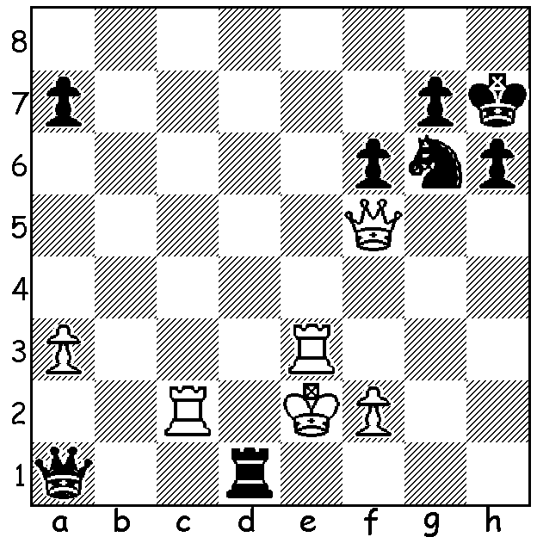

Kateryna Lagno vs Ju Wenju
(Cairns Cup 2020):
the Womens World Champion (Black)
pulls off a spectacular finish:

CARLSEN'S RECORD
Last week I commented on Fabiano Caruana's top place in the annual Tata Steel Masters in the Netherlands, two points ahead of world champion Magnus Carlsen. Both players were undefeated with Carlsen breaking the record for most number of classic games without defeat which had stood at 110. After passing the record at Game 4, Carlsen now is on 120 without loss. The previous record holder was Sergei Tiviakov, a three times Dutch champion and former European champion (2008). Other long runs include Liren Ding 100, Mikhael Tal 95 & 86, Vladimir Kramnik 82, Wesley So & Maxine Vachier-Lagrave 67 and Jose Raul Capablanca 62 (which stretched over a number of years). I attempted unsuccessfully to find the record of most wins between losses (ignoring draws) but I did discover the most number of consecutive wins; this was achieved by Wilhelm Steinitz, 25 wins in succession, while in 1971 Bobby Fischer won 20 consecutive games which included his 6-0 Candidate victories against both Mark Taimanov and Bent Larsen on his way to his match with Boris Spassky.

WOMENS WORLD CHAMPION OVERTAKEN NEAR FINISH

The Cairns Cup, played in St Louis,USA,
and featuring ten of the world's leading
female players, finished this week with
Womens Rapidplay champion Humpy
Koneru (India) taking off first prize of
$45,000 after scoring 6/9 (+4 =4 -1).
Womens World Champion Ju Wenju led
the field going into the penultimate round
before losing to US teenager Carissa Yap
who had lost her first four games before
scoring 4/5 in the latter rounds.
Humpy Koneru

PERTH OPEN
The Perth Open, played last weekend, was won by Patrick Gong (6/6). Patrick defeated two of WA's leading players, former WA champion Tristan Boyd (4/6) and Adam Kelly (4/6), on his way to his picket fence score. Yihu (Rebo) Fu and Eelke de Boer (4) shared the Under 1800 prizes and Benjamin Foster (3) won the Under 1600 award.

SOLUTION: 1...Rd5! (threat 2...Qd1#): if 2.Qxd5 Nf4+.

