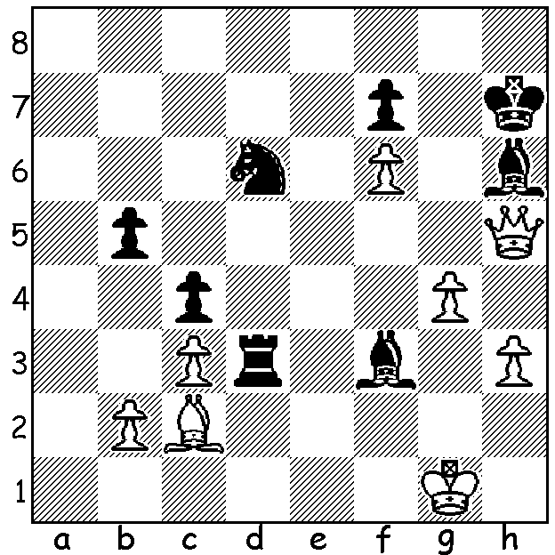

Alireza Firouzja vs Nikita Vitiugov
(Prague 2020)
How can White win?
You may find this puzzle is either
very difficult or extremely simple
(clue: the tactical motif is usually
seen in the endgame).

FIROUZJA'S SUCCESS IN PRAGUE
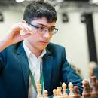
16 year old Iranian Alireza Firouzja has won the Prague
Masters after defeating Santosh Vidit (India) 2-0 in a
blitz playoff. Vidit had seemed to be heading for outright
first place before losing his final two games. In fact five
of the ten players finished with the top score of 5/9 with
three eliminated at the end on countback. One of those on
5/9 was American Sam Shankland who was on a minus
score and without a win after six of the nine rounds. The
chess was very exciting with players often unable to
capitalise on winning positions and losing. Readers will
recall that Firouzja is under a ban in Iran for playing an
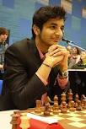
Israeli and may seek French citizenship.

WA ALLEGRO CHAMPIONSHIP
One of the major tournaments of the year, the WA Allegro
Championship (Rapidplay 15min + 2sec), will be take place
on Sunday 8 March at Leeming Primary. Nine rounds will be
played with starting time 11am.
Full details and entry cawa.org.au

SOLUTION: How could White win? By doing nothing! It's
called Zugzwang and means not really altering the position
and leaving the opponent with only losing moves. All Black's
pieces are either immobilised or needed on the squares they Firouzja (top) & Vidit
are on - the rook and h6 Bishop are pinned, the King protects
the bishop, the f3 Bishop prevents g5, the Knight protects the f pawn and 1...b4, merely loses the pawn leaving Black again without a good move. Therefore 1.Bb1! (1.Kf1 could also be played) and if 1... Be2 2.Kf2 2.Bf3 (2...Ne4+ 3.Ke1!) 3.Ke1 Zugzwang! With both players down to less than one and a half minutes each the move chosen was 1.Qe5 (which releases the pinned bishop) 1...Bf8 2.Kf2 Ne4+ 3.Kf1 Kg8 4.Qxb5 Rd5! 5.Qb8 Rd2 6.Bxd4 Bxe4 7.h4 Bd3+ 8.Kg1 Be4 9.Kf1 Bd3+ and a draw by repetition resulted.

