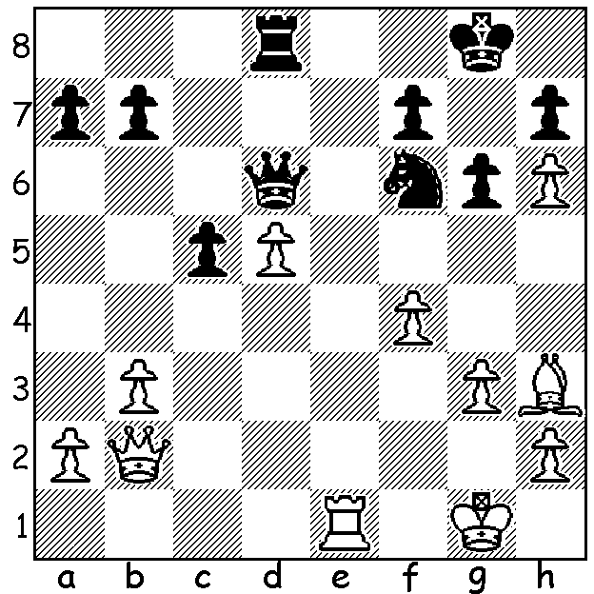
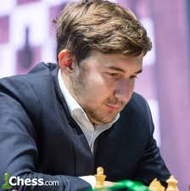
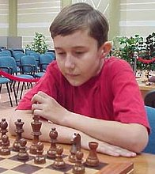

Karjakin vs Zavgorodniy 2001: How does the 11
year old prodigy Karjakin (White) win (4 moves)?

YOUTH TRIUMPHS AGAIN
This week we again see youth triumph in tournament
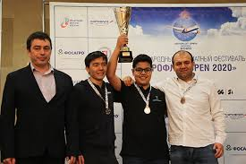
play. The successful junior this time is World Under
14 Champion Aydin Suleymanli from Azerbaijan, who
won the 18th Aeroflot tournament in Moscow despite
being ranked a lowly 71st among the 97 competitors.
Aydin finished equal first to fourth with 6.5/9 but took
the title on tie break (one through having more Blacks
and two from superior totals of opponents' ratings).
Eydin, rated 2474, was given special dispensation to
play as the A group is intended for players over 2550.
Azerbaijan has a strong tradition of chess players including former world champion, the great Garry
Kasparov, and, among present day players, Shakhriyar
Mamedyarov and Teimour Radjabov both among
the world's top ten, as well as Rauf Mamedov, one of Top place getters at Aeroflot (l to rt):
the four in the Aeroflot tie. Another outstanding junior Rinat Jumabayev, Aravindh
was 12 year old Bharath Subramanyam from India Chithambaram, Aydin Suleymanli and
(India had 25 players in the tournament, the equal of his compatriot Rauf Mamedov
the Russian hosts) who came 11th, scoring 5.5/9 and
earning a GM norm.

WA ALLEGRO CHAMPIONSHIP TOMORROW
One of the major tournaments of the year, the WA Allegro Championship (Rapidplay 15 min + 2 sec), takes place tomorrow at Leeming Primary. Nine rounds will be played with starting time 11am. Full details and entry cawa.org.au

SOLUTION: 1.Re6! fxe6 (1...Qxd5 2.Qxf6!) 2.Bxe6+ (not 2.Qxf6? Qd4+) 2...Kf8 3.Qxf6+ Ke8 4.Qf7#. Karjakin holds the record as the youngest ever Grandmaster, gaining the title when 12 years 7 months 0 days.

